Seismic Radiation from an Explosion in Rock Having an Anisotropic Distribution of Fractures

Marshall Rogers-Martinez1, Charles G. Sammis1, and Harsha Bhat2

*Draft July 30, 2019*

**Abstract**

The dynamic micromechanical damage mechanics formulated by Bhat et al. (2012) is modified to model explosions in rock having an anisotropic initial distribution of fractures. This is achieved by decreasing the fracture toughness for tensile cracks oriented in the rift plane as indicated by experiments and the linear fracture mechanics of an array of aligned fractures. The anisotropic damage mechanics is implemented as a subroutine in the ABAQUS 3D finite element program and used to explore the effects of both isotropic and anisotropic damage on the seismic radiation from an explosion in a granite half-space. Model predictions are compared with field observations of a chemical explosion in a Barre granite quarry, where the granite has a strong rift plane that produces a 20% azimuthal variation in acoustic velocities. The model generates the fracture pattern produced by the explosion, which is elongated in the rift plane. It also reproduces the observed seismic radiation pattern of S/P amplitude ratios which are consistent with a tensile crack oriented parallel to the rift. The point moment tensor calculated directly from an integration over damaged elements in the source region is a linear combination of an isotropic component, a crack-like component, and a CLVD component which combine to produce the observed crack-like source. When plotted on a Hudson source-type diagram, the combined moment tensor looks like a tensile crack lying in the rift plane comparable to that observed in many underground nuclear explosions.

# Introduction

Since the advent of underground nuclear testing in the 1960s, seismic radiation has been used to discriminate between explosions and earthquakes, and to estimate explosive yield. Discrimination should be simple. An explosion should generate only compressional P waves while slip on a fault plane during an earthquake should also generate shear S waves. The observation that explosions generate significant S wave energy has made discrimination difficult, and has motivated research to identify the source of these S waves.

The S waves observed to radiate from an explosion can be either a path effect or a source effect. P waves can be converted to S waves along the path from source to receiver by reflection or refraction at boundaries and scattering by heterogeneities. S waves can also be generated directly within the source region of an explosion by any process that breaks spherical symmetry. Such processes include the asymmetric placement of the device in the underground cavity (Stevens and Baker 2009), the release of tectonic shear stress (Archambeau and Sammis 1971; Johnson and Sammis 2001), and the anisotropic distribution of cracks in rock at the source (Johnson and Sammis 2001; Mandal and Toksoz 1991). The generation of S waves by explosions is closely related to the observation that the point force moment tensors calculated for many nuclear explosions are not purely isotropic (Ford et al. 2009).

This study focuses on the generation of S waves by an explosion in rock that contains an anisotropic distribution of cracks. In this case, two mechanisms have been identified that break spherical symmetry and produce S waves. First, an anisotropic crack distribution produces anisotropic elasticity. Consider a rock in which the preferential alignment of cracks defines a “rift direction” or “rift plane”. The effective elastic stiffness for a compression normal to the rift plane will be smaller than that for a compression parallel to rift plane because the former closes cracks while the latter does not. An explosion in an initially spherical cavity will produced an elliptical source with its major axis normal to the rift plane (Mandal and Toksoz 1991).

A second mechanism by which an explosion can generate S waves in an anisotropic medium is the preferential activation of fractures in the rift plane. Johnson and Sammis (2001) explored this mechanism using the Ashby and Sammis (1990) micromechanical damage mechanics. They modeled fracture anisotropy by increasing the initial damage at azimuths where fractures in the rift plane are optimally oriented for shear. For a vertical and N striking rift plane, Johnson and Sammis predict zones of maximum damage in the NE, NW, SE and SW azimuths as in Fig. 1.



**Figure 1**  Geometry of damage generated by an explosion in an anisotropic fractured medium predicted by Johnson and Sammis (2001). Since only compressive loading is considered, damage is greatest where the pressure from the explosion causes maximum sliding on initial fractures in the rift plane.

The damage pattern predicted by Johnson and Sammis (2001) in Fig.1 differs from that observed in the New England Damage Experiments, NEDE and NEDE2, (Martin and Boyd 2012). In the NEDE experiments a series of shallow chemical explosions in a granite quarry produced the ellipsoidal damage zone shown in Fig. 2 and not the four-lobed pattern in Fig. 1 predicted by Johnson and Sammis (2001). In the NEDE experiments, the major axis of the damage ellipse (Fig.2) was aligned with the rift plane. The implication is that the damage pattern in not controlled by and excess of sliding on cracks in the rift, as assumed by Johnson and Sammis (2001), but by the preferential opening of excess rift cracks in tension.

Another problem with the Johnson and Sammis (2001) model is that the Ashby and Sammis (1990) damage mechanics is only applicable to compressive loading – damage only nucleates and grows in response to sliding on optimally oriented initial cracks that are loaded in compression. Deshpande and Evans (2008) and Bhat et al. (2012) fixed this shortcoming by extending the Ashby and Sammis (1990) formulation to include tensile stress states, which occur during the dilatational phase of the explosive pressure wave. These latter studies also include the effects of loading rate on crack growth, which are important at the high loading rates in an explosion and are not considered in the quasi-static Ashby and Sammis (1990) mechanics.

Bhat et al. (2012) implemented their dynamic formulation as a user-defined material subroutine in the ABAQUS/EXPLICIT commercially available finite element program. This study modifies the Bhat et al. (2012) formulation to include the effects of an anisotropic distribution of initial flaws, which is implemented in ABAQUS exactly as described by Bhat et al. (2012). ABAQUS is then used to generate a 3D simulation of one of the NEDE explosions in a granite half-space in order to explore the effects of fracture anisotropy on the damage pattern, the seismic radiation, and the equivalent point-force moment tensor. The effects of fracture anisotropy on the elasticity are ignored in order to focus on the effects damage evolution.

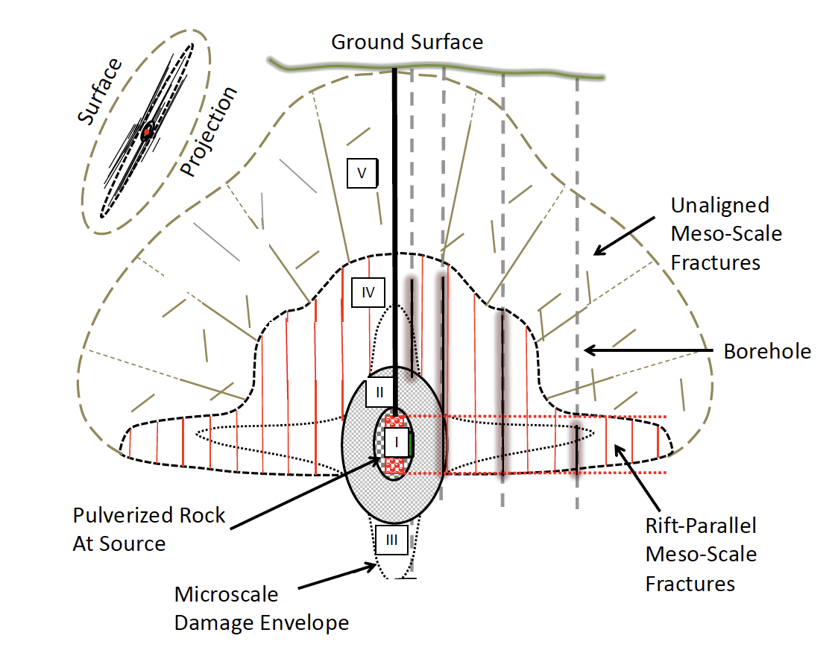

**Figure 2** Damage pattern produced by NEDE explosion #4. In region I the rock is totally pulverized. In regon II the rock is granulated. In region III there is extensive microscale damage. In region IV there are rift-parallel mesoscale fractures and in region V there are unaligned meso-scale fractures. Note that the fracture damage extends vertically and horizontally following the rift plane. These directions are optimal for damage creation during the first dilation phase of the pressure front when the transverse stress becomes tensile. (Redrafted from Martin and Boyd 2012)

# 

# Micromechanical Damage Mechanics

The Ashby and Sammis (1990) micromechanical damage mechanics and subsequent extensions by Deshpande and Evans (2008) and Bhat at al. (2012) all assume that the material has a homogeneous initial distribution of randomly oriented penny-shaped fractures all having the same radius *a*. For a local stress field characterized by a largest principal stress **1 and a smallest principal stress **3, only those cracks that are optimally oriented for sliding in shear are assumed to be activate and to nucleate tensile wing-cracks at their tips as illustrated in Fig. 3. All other local crack orientations are ignored. Although these assumptions may seem extreme, Bhat et al. (2012) demonstrated that consideration of range of penny-crack sizes and orientations did not significantly affect the results once the model parameters were constrained by the observed nucleation and failure stresses.

In these models, a dimensionless initial damage was defined as

$D_{0}=\frac{4}{3}πN_{V}{\left(αa\right)}^{3}$, (1)

where *NV* is the density of optimally oriented penny-cracks, , and  is the local angle between an optimally oriented penny-crack and **1 as in Fig. 3.

When the applied stress **1 is increased beyond that required for wing-crack nucleation, the wing-crack length *l* increases as does the damage, which is defined as

$D=\frac{4}{3}πN_{V}{\left(l+αa\right)}^{3}$. (2)

The growing wing cracks interact by inducing a tensile stress on their neighbors that enhances their growth. This positive feedback leads to unstable propagation and failure.

Ashby and Sammis (1990) calculate the shear and normal stresses on each initial crack from the maximum and minimum principal local compressive stresses **1 and **3 as

. (3)

To facilitate numerical implementation, Bhat at al. (2012) assumed the normal stress is represented by the first invariant and the shear stress by the second invariant the of the stress tensor.

$σ=\frac{σ_{kk}}{3}$ $τ=\sqrt{\frac{1}{2}S_{ij}S_{ij}}$ (4)

where $S_{ij}=σ_{ij}-σδ_{ij}$ and $δ_{ij}$ is the Kronecker delta. The optimal angle for Coulomb frictional sliding on the penny-cracks is $Ψ=\tan^{-1}\left(1/f\right)$ where *f* is the coefficient of static sliding which, for most rocks, is *f* = 0.6.

In the Ashby and Sammis (1990) formulation the normal stress ** on the sliding cracks in Fig. 3 is always compressive. Deshpande and Evans (2008) and Bhat et al. (2012) extended the analysis to the case where ** is may be tensile and the entire crack of length $2\left(l+αa\right)$ is loaded in tension.



**Figure 3** Geometry in the micromechanical damage mechanics model. Sliding on an array of penny-shaped cracks having radius *a* and volume density of *NV* produces a wedging force *Fw* that drives tensile wing cracks to open in the direction of the smallest principal stress **3 and propagate parallel to the largest principal stress **1. Growth of wing-cracks is enhanced by **1, retarded by **3, and enhanced by a global interaction that produces a mean tensile stress $σ_{3}^{(i)}$. The positive feedback provided by this tensile interaction stress leads to a run-away growth of the wing cracks and ultimate macroscopic failure. (Redrawn from Bhat et al. 2012).

Bhat et al. (2012) identify three loading regimes. In regime I the remote loading is compressive but not large enough to overcome frictional resistance on the penny-cracks. In this regime the solid behaves like an isotropic linear elastic solid. In regime II the remote stresses are large enough to overcome friction and produce sliding on the penny-cracks leading to the nucleation and growth of tensile wing-cracks from their tips. In regime III the remote loading is tensile which produces an opening of both the penny-cracks and the wing-cracks. Bhat et al. (2012) derive expressions for the mode I stress intensity factor at the tips of the growing wing cracks in regimes II and III.

Regime II was analyzed by Ashby and Sammis (1990) where they found three components of the Mode I stress intensity factor: 1) a wedging force on the wing cracks due to sliding on the penny-cracks, 2) the remote confining stress, approximated here as **, which tends to close the wing cracks, and 3) a global interaction term in which the wedging force on one crack tends to increase the tension at the tips of its neighboring cracks. As the wing cracks grow and the distance between them decreases this interaction term dominates and leads to unstable growth and global failure.

Following Bhat et al. (2012), the Mode I stress intensity factor in regime II can be written

$K_{I}^{R-II}=\frac{\left(τ+fσ\right)πa^{2}sinΨ}{{\left[π\left(l+βa\right)\right]}^{3/2}}+\frac{2}{π}\left(σ+σ^{(i)}\right)\sqrt{πl}$ (5)

where ** is a factor introduced by Ashby and Sammis (1990) to give a limiting value to $K_{I}^{R-II}$ when the length of the wing crack approaches zero. The interaction term in eqn. (2.5) is

$σ^{(i)}=\frac{\left(τ+fσ\right)πa^{2}sinΨ}{A_{crack}-π{\left(l+αa\right)}^{2}}$ (6)

In this expression $A_{crack}=π^{1/3}{\left(\frac{3}{4N_{V}}\right)}^{2/3}$ is the average area occupied per crack.

Rewriting eqn (5) in terms of *D0* and *D*

(7)

where

$A\left(D\right)=fc_{1}\left(D\right)+c_{3}\left(D\right)\left[fc_{2}\left(D\right)+1\right]$ (8)

$B\left(D\right)=c_{1}\left(D\right)+c_{2}{\left(D\right)c}_{3}\left(D\right)$ (9)

and

$c_{1}\left(D\right)=\frac{\sqrt{1-α^{2}}}{πα^{3/2}{\left[{\left(D/{D_{0}}\right)}^{1/3}-1+β/α\right]}^{3/2}}$ (10)

$c_{2}\left(D\right)=\left(\frac{\sqrt{1-α^{2}}}{α^{2}}\right)\frac{\left(D_{0}^{2/3}\right)}{1-D^{2/3}}$ (11)

$c_{3}\left(D\right)=\left(\frac{2\sqrt{α}}{π}\right){\left[{\left(D/{D_{0}}\right)}^{1/3}-1\right]}^{1/2}$ (12)

Note that eqn. (8) is from Thomas et al. (2017) which corrects an error in Bhat et al. (2012).

In Regime III the overall remote loading stress is tensile and Bhat et al. (2012) write the Mode I stress intensity factor as a quadratic function of the stress

$K_{I}^{R-III}\left(σ,D\right)=\sqrt{πa}{\left[C^{2}\left(D\right)σ^{2}+E^{2}(D)τ^{2}\right]}^{1/2}$ (13)

By requiring that elastic strains match at the transition between a remote and a compressive stress state, they relate parameters *C*(*D*) and *E*(*D*) to *A*(*D*) and *B*(*D*) as

$E^{2}=\frac{B^{2}C^{2}}{C^{2}-A^{2}}$ (14)

and

$C=A+Ω\sqrt{α{\left(\frac{D}{D_{0}}\right)}^{1/3}}$ (15)

where  is a crack shape factor that is set to  = 2.

Transition criteria between regimes can be written in terms of *A*, *B*, and *C* as follows:

In Regime I

$Aσ+Bτ≤0$ (16)

In Regime II

$Aσ+Bτ>0$ and $\left(A^{2}-C^{2}\right)σ+ABτ<0$ (17)

In Regime III

$Aσ+Bτ>0$ and $\left(A^{2}-C^{2}\right)σ+ABτ>0$ (18)

At this point the original Ashby and Sammis (1990) formulation (Regime II) has been extended to tensile loading (Regime III), and a criterion has been found for the transition between the two regimes. However crack growth is still quasi-static. The stress intensity at the tips of the wing cracks is always assumed to be that of the static crack in equilibrium with the external load. The length of the wing crack *l* is always assumed to be the value for which (depending on the relevant regime) either $K_{I}^{R-II}=K_{IC}$ or $K_{I}^{R-III}=K_{IC}$, where $K_{IC}$ is the critical stress intensity factor for the wing crack at zero velocity. In Regime II, if the stress at the wing-crack tip increases, its length is increased until $K_{I}^{R-II}$ falls to the static critical value $K_{IC}$. Crack growth is stable. In Regime III, crack growth is unstable once $K_{I}^{R-III}$ reaches or exceeds $K_{IC}$. In this case, crack velocity is limited by dynamic constraints.

The next step is to write an expression for damage evolution that incorporates theoretical and experimental crack growth laws. Following Bhat et al. (2012) damage evolution can be related to the instantaneous speed of the wing-crack tips $v=\frac{dl}{dt}$ by differentiating the damage parameter *D* with respect to time

$\frac{dD}{dt}=\left(\frac{3D^{2/3}D_{0}^{1/3}}{αa}\right)\frac{dl}{dt}$. (19)

The quasi-static model assumes that the crack-tip speed required to reduce the damage in order to maintain *KI* = *KIC* is physically possible. However, crack growth lags behind loading at the high loading rates typical of explosions, impacts, and propagating earthquake ruptures. There are three reasons why the nucleation and growth of wing cracks cannot keep up with the increase of stress at their tips. First, the stress intensity factor at the crack tip decreases at high crack velocities reaching zero when the crack speed reaches the Rayleigh wave speed for the medium (Freund, 1973). Second, the critical stress intensity factor for Mode I nucleation increases with increased loading rate. Third, the critical stress intensity factor for Mode I propagation also increases with increased loading rate. The decrease in *KI* and accompanying increase in *KIC* at high loading rates explains why materials are observed to grow stronger as loading rate increases. Following Bhat et al. (2012) we now discuss equations that govern these three effects.

The dynamic stress intensity factor at the tip of a propagating crack can be expressed as a universal function of the instantaneous crack-tip speed *v(t)* multiplied by the equilibrium stress intensity factor $K_{I}^{SS}$ for the applied load and crack length at time t.

$K_{I}^{d}\left[v\left(t\right)\right]=K_{I}^{SS}\left[σ\left(t\right),l\left(t\right)\right]\frac{\left(1-v/{c_{R}}\right)}{\sqrt{1-v/{c_{P}}}}$, (20)

where *cR* is the Rayleigh wave speed and *cP* is the compressional wave speed of the medium.

The critical stress intensity for dynamic nucleation $K_{IC}^{D}$ and that for dynamic propagation $K_{IC}^{d}$ can only be obtained through experimental measurement. Nucleation experiments have found that the dependence of $K_{IC}^{D}$ on loading rate can be expressed in terms of a parameter ${\dot{K}}_{I}$ that characterizes the loading rate and is defined as ${\dot{K}}_{I}=\frac{K_{IC}}{t_{C}}$ where *KIC* is the mode-I critical stress intensity factor at the instant of crack initiation and *tC* is the time interval between the onset of loading and nucleation of the wing-crack. The critical stress intensity factor for dynamic nucleation is expressed in terms of ${\dot{K}}_{I}$ as $K_{IC}^{D}=f_{D}\left({\dot{K}}_{I} \right)K_{IC}^{SS}$. Bhat et al. (2012) show that the functional form

$f_{D}\left({\dot{K}}_{I}\right)=1+\left(\frac{{\dot{K}}_{I}}{K_{IC}^{SS}}\right)×2×{10}^{-5}$ (21)

gives a good fit to dynamic nucleation data, and that experimental measurements for the critical stress intensity factor for dynamic propagation can be represented by the functional form,

$K_{IC}^{d}\left(v\right)=K_{IC}^{SS}\left\{\frac{1+{\left(v/{v_{m}}\right)}^{5}}{\sqrt{1-v/{c_{P}}}}\right\}$ (22)

The wing-crack will nucleate when $K_{I}^{d}\left(v=0,{\dot{K}}_{I}\right)=K_{IC}^{D}\left({\dot{K}}_{I}\right)$, where KI is the stress intensity factor from eqn. (7) or (13) depending on the loading regime.

Equating $K_{I}^{d}=K_{IC}^{d}$ gives a non-linear equation for the crack-tip speed

$K_{I}\frac{\left(1-v/{c_{R}}\right)}{\sqrt{1-v/{c_{P}}}}=K_{IC}^{SS}\left\{\frac{1+{\left(v/{v_{m}}\right)}^{5}}{\sqrt{1-v/{c_{P}}}}\right\}$ (23)

This expression can be solved for the crack speed *v*, which is then used in the damage evolution equation to find the change in damage at each time step.

$\frac{dD}{dt}=\left(\frac{3D^{2/3}D_{0}^{1/3}}{αa}\right)v$ (24)

Bhat et al. (2012) have implemented the dynamic damage mechanics as a user-defined rheology subroutine in the commercial finite element package ABAQUS.

## **Damage Mechanics of Materials with an Anisotropic Distribution of Initial Fractures**

As in the previous section, consider a material with a volume density *NV* of penny-shaped fractures all having the same radius *a*. While the orientation of most of these penny-cracks is assumed be random, a small subset is assumed to be aligned to form a rift plane. One effect of the aligned cracks is that they interact to increase the stress intensity factor on each individual member of the set (Tada et al. 2000). Figure 4 shows a linear array of fractures under tensile loading and the stress intensity factor at the tip of each fracture in the array as a function of scaled spacing. Note that the stress intensity increases by a factor of two or more as the scaled spacing decreases. Hence, fractures in the array will grow at a lower value of external stress than will unaligned fractures. This effect has been measured in fracture tests on Barre Granite where the fracture toughness has been observed to be a factor of 2.5 smaller for tensile fractures propagating in the rift plane (Nasseri and Mohanty 2008). The interaction of aligned cracks in the rift zone is incorporated in the micromechanical damage mechanics by decreasing their critical stress intensity factor. This has the same effect as raising their stress intensity factor since they nucleate and grow at a lower value of the local stress.

The “rift zone” is defined as the wedge-shaped disc shown in Fig 5, which is defined by $\frac{π}{2}-β<θ<\frac{π}{2}+β$, $0<ϕ<2π$. The critical stress intensity factor is decreased linearly from its nominal value of $\overline{K_{Ic}}$ at the edge of the rift zone to $\overline{K_{Ic}}$/4 at the center.

The subset of aligned fractures will also affect the growth of damage in compressive regime II by adding to the density of initial fracture that are optimally aligned for sliding at azimuths 45°, 135°, 225°, and 315. This is the effect modeled by Johnson and Sammis (2001) that gave the quadrupole damage pattern in Fig. 1. We ignore this effect and focus on enhanced growth in the rift plane. The effects of elastic anisotropy are also ignored in the simulations.

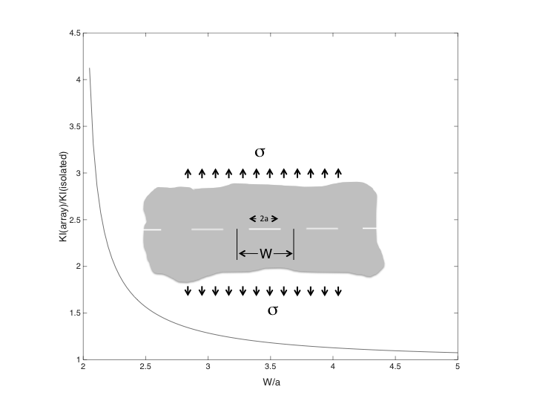

**Figure 4**. Enhancement of the stress intensity factor at the tips of tensile cracks in a linear array as a function of their scaled spacing. Note that the stress intensity can be increased by a significant factor as the spacing between cracks decreases.



**Figure 5** The rift-zone is defined as a wedged shape disc making an angle ** relative to the *x2*, *x3*

plane with rotational symmetry about the *x1* axis.

## **Modeling a NEDE Explosion**

The anisotropic damage mechanics developed in the previous section is used to model the fracture pattern and seismic radiation and point force moment tensor generated by a chemical explosion in a granite quarry. This explosion was one of the New England Damage Experiments (NEDE and NEDE2), which were a series of field experiments designed to investigate the generation of S-waves by explosive sources as well as the seismic-decoupling effects of the mesoscale damage zone created by a previous explosion. The first phase experiment (NEDE) was conducted in July 2008, at the Rock of Ages granite quarry in Barre, VT (Leidig et al. 2010; Stroujkova et al. 2012). The second phase experiment (NEDE2) was conducted in June 2013, in the same Barre, VT quarry (Stroujkova et al. 2014).

The first series of experiments (NEDE) were designed to study the effects of different velocities of detonation (VOD or burn-rates) on S-wave generation. Explosives with faster VODs (ANFO & COMP-B) had near-field accelerations that exceeded gravity while explosives with slower VODs (Black Powder) produced accelerations smaller than that of gravity. The relatively weaker near-field accelerations produced by Black Powder were attributed to the Black Powder producing more damage in the rock layer above the shot (Martin et al. 2011). Although the explosives with faster VODs produced more seismic energy, they also produced fewer radial fractures. Perhaps the most significant finding of the original NEDE experiments was the correlation between large radial fractures, large S-wave amplitudes and slower VODs. A high loading rate with a shorter impulse, as is produced by faster VOD explosives, inhibits fracturing around the source and thereby reduces the production of S-wave radiation (Stroujkova et al. 2012).

The second series of experiments (NEDE2) were designed to answer the same questions as the original NEDE experiment as well as to quantify the decoupling effects of pre-existing rock damage surrounding an explosive source. The NEDE2 experiments were designed with equivalent TNT energy yields to allow a direct analysis of the effects of burn rate on damage and S-wave generation. A control explosion was also detonated in undamaged rock in order to quantify the decoupling effects of the damage zones from the first series of NEDE experiments in 2008. The most important seismological observation of NEDE2 was an elliptical reduction in P-wave amplitudes at a 6 km circular array for explosives detonated in the damage zones from the NEDE series of experiments. P-wave amplitudes were most reduced in the direction of the aligned microfractures. Stroujkova et al. (2014) attributed this amplitude reduction to the larger velocity changes and more extensive damage in the direction of the aligned microfractures created during the first series of NEDE experiments (Martin and Boyd 2012). At those azimuths exhibiting large amplitude reductions, the amplitude reduction was nearly uniform across the entire frequency band.

Rock at the NEDE test site is Barre granite, a transversely isotropic monument grade granite (Martin et al. 2011). The transverse anisotropy of the Barre granite is the result of a series of vertically aligned microfractures that were produced by thermoelastic stresses during the exhumation of the granitic body (Nadan and Engelder 2009). Compressional waves propagating parallel to the rift plane travel 20% faster than those propagating orthogonal to it (Martin and Boyd 2012). Xia et al. (2008) measured the initial flaw size in Barre granite and its compressive strength. Since these were comparable to those in Westerly granite, we used the flaw size and initial damage for Westerly granite from Ashby and Sammis (1990).

This paper is focused on experiment #4 in the first suite of NEDE field experiments. Experiment #4 was a 122.7 kg ANFO detonation. The top of the cylindrical charge was at a depth of 12.8 m, while the bottom was at 13.7 m. We model the explosion as a spherical cavity with a 1 m radius centered at a depth of 13 m and having a prescribed pressure history. Parameters used to model this experiment are discussed in Appendix A and summarized in Table 1. The experimental configuration is shown in Fig. 6.

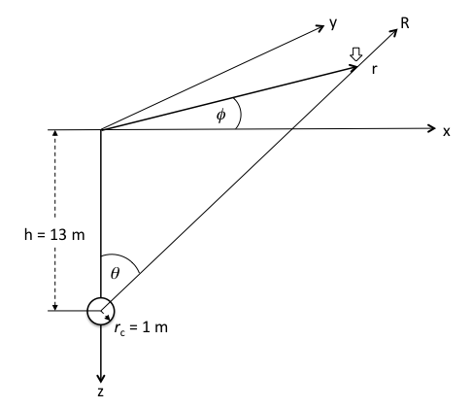

**Figure 6** Source and receiver geometry for simulation of NEDE experiment #4. The block arrow indicates a receiver at surface coordinates (x,y,0) or (r,**,0) and source coordinates (R,**). The rift plane is taken as the y-z plane for the anisotropic model.

**Table 1 Model Parameters**

|  |  |  |  |
| --- | --- | --- | --- |
| MATERIAL PROPERTIES  BARRE GRANITE | VALUE | UNITS | REFERENCES |
| *vP*||(P wave speed parallel to the rift) | 4,600 | m/s | Martin and Boyd (2012) |
| *vS*I|(S wave speed parallel to the rift) | 2,655 | m/s | From *vP* assuming =0.25 |
| *vP*⊥(P wave speed perpendicular to rift) | 3,850 | m/s | Martin and Boyd (2012) |
| *vS*⊥(S wave speed perpendicular to rift) | 2,222 | m/s | From *vP* assuming =0.25 |
| *    *(density) | 2,600 | kg/m3 | Martin and Boyd (2012) |
| *D0* (initial damage) | 0.01 | - | Ashby and Sammis (1990) |
| *2a* (initial flaw diameter) | 1 | mm | Xia et al. (2008) |
| $\overline{K_{Ic}}$ (critical stress intensity factor) | 1 | MPa m1/2 | Ashby and Sammis (1990) |
| *vm* (crack branching speed) | 866 | m/s | Bhat et al. (2012) |
| EXPLOSION PARAMETERS | VALUE | UNITS | EFEREN REFERENCES |
| *h* (depth of burrial) | 13 | m | Martin and Boyd (2012) |
| *rc* (cavity radius) | 1 | m | Martin and Boyd (2012) |
| *Pc* (peak explosion pressure) | 51.5 | MPa | Appendix A |
| ** (explosion rise time) | 25 | ms | Appendix A |

The source and receiver geometry in Fig. 6 was used in the ABAQUS meshing tool to design the finite element mesh shown in Fig. 7. The elements were 8 node hexahedra (C3D8R) that varied in size across three nested regions. In the inner region they varied from 2 cm near the source to 35 cm at the boundary with the second region. In this innermost region the geometry graded from spherical at the source to Cartesian at the boundary. In the second region the elements were quadrilateral frustums with radial edges and ends parallel to the Cartesian boundaries. Their dimensions varied smoothly from 92 cm to 13 m. In the third region the elements were strictly Cartesian with an edge length of 26 m. The boundaries between the three regions were tied using a surface-based interpolation constrain included in ABAQUS. The entire mesh comprised a total of 1.86x106 elements and 1.91x106 nodes.

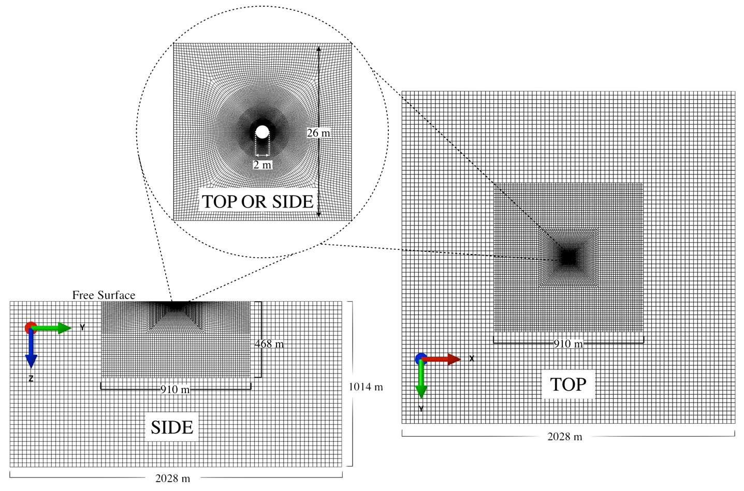

**Figure 7** Finite element mesh used to simulate the NEDE #4 explosion.

We used the source parameters in Table 1 and the mesh in Fig. 7 to explore 3 cases: 1) an elastic half-space, 2) a half-space with a homogeneous isotropic distribution of damage, and 3) a half-space with an anisotropic distribution of initial damage. The source and receiver geometry in Fig. 6 is the same for all three cases. For the anisotropic case, the aligned initial fractures are assumed to lie in the *y-z* plane with normal vectors in the *x* direction.

### Case 1 – Elastic Half Space

The response of an elastic half space to the source specified in Table 1 was calculated using the VUMAT subroutine in which the initial damage was set to $D_{0}≈0.$ As a check, the elastic response was also calculated using the elastic solver that is built into MATLAB. Both gave the same results. Figure 8 shows the vertical and horizontal surface displacements as a function of time for a range of scaled epicentral distances *r/h*.

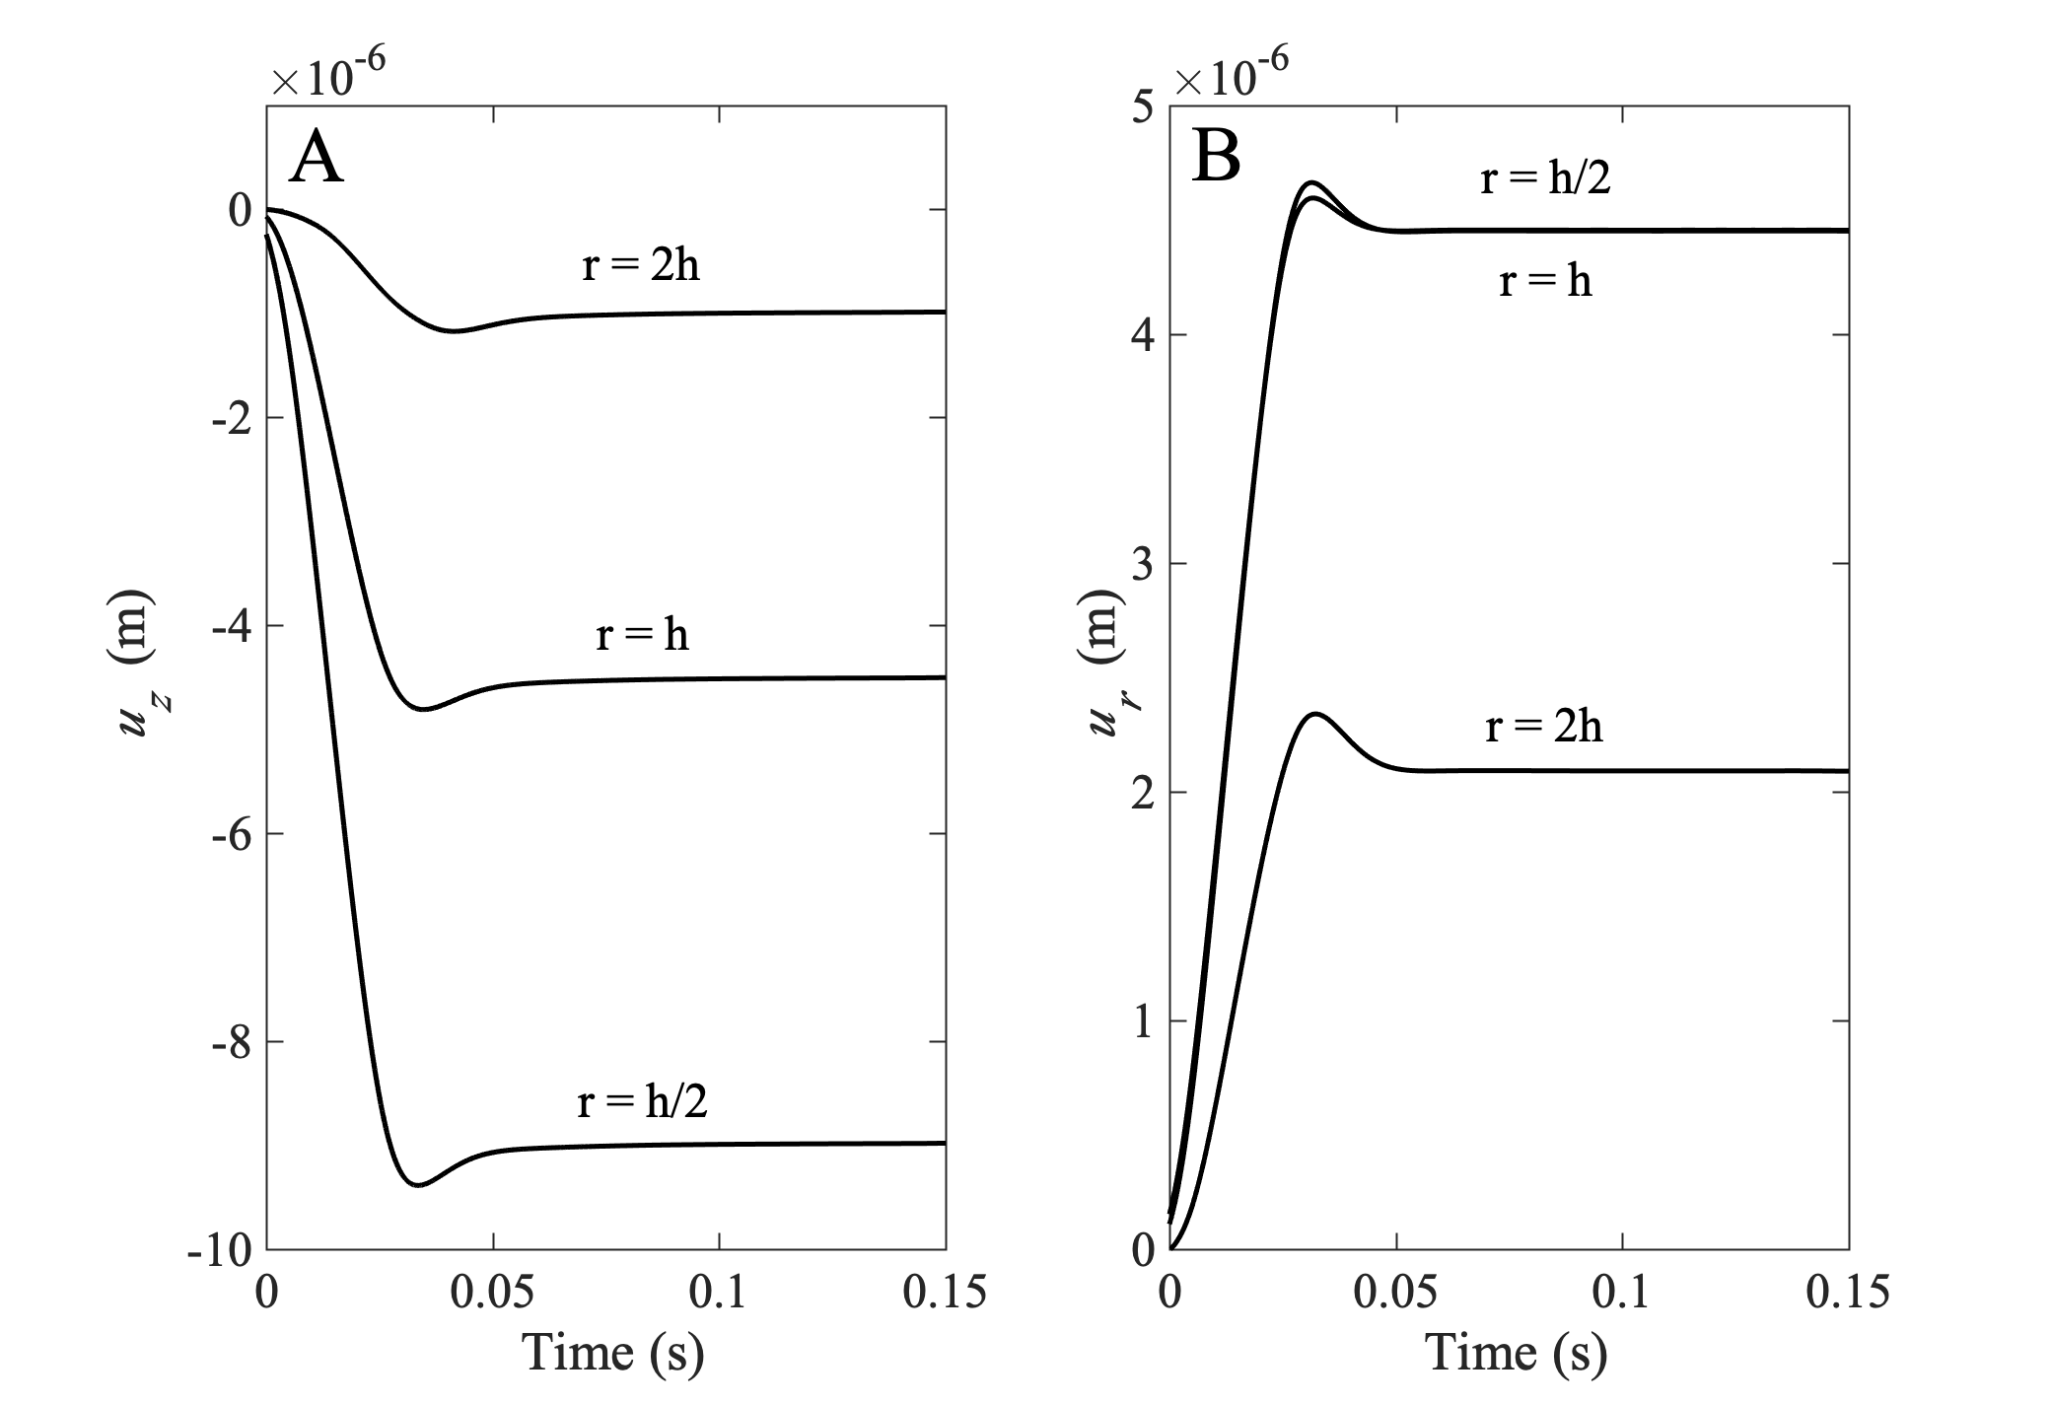

**Figure 8** Displacement seismograms at the free surface for a range of scaled epicentral distances for an elastic half-space with source parameters specified in Table 1. Panel A shows vertical displacements. Note that *z* is positive down as in Fig. 6. Panel B shows horizontal displacements. Note that *r* is the vector from the epicenter to the station as in Fig. 6.

There is no simple analytic solution for elastic waves generated by a spherical pressure source in an elastic half-space (see, e.g., Ben-Menahem Cisternas 1963), but there are analytic solutions for the final static displacements that can be used as a check on Fig. 8. The vertical and horizontal static surface displacements at epicentral distance *r* generated by a point source of pressure *Pc* source at depth *h* are (Mogi 1958)

$u_{z}\left(0,r\right)=h\frac{P_{c}}{G}ϵ^{3}\frac{3}{4}\frac{h^{3}}{{\left(h^{2}+r^{2}\right)}^{3/2}}$ (25)

$u_{r}\left(0,r\right)=\left(\frac{r}{h}\right)u_{z}\left(0,r\right)$ (26)

Equations (25) and (26) are strictly true when the source radius is much less than the depth ($ϵ=r_{c}/h→0$). McTigue (1987) gives the first order correction to Mogi’s equation for a finite source radius including terms to order ${\left(r_{c}/h\right)}^{6}$. For the case we are considering here, $\frac{r_{c}}{h}=1/12$, the higher order equations are essentially identical to Mogi’s equations (25) and (26), which are plotted in Fig. 9. The static displacements from Fig. 8 are also plotted as points on Fig. 9 where they agree with the analytic curves. This confirms that our VUMAT damage mechanics subroutine gives the correct static displacement in the limit of no damage.

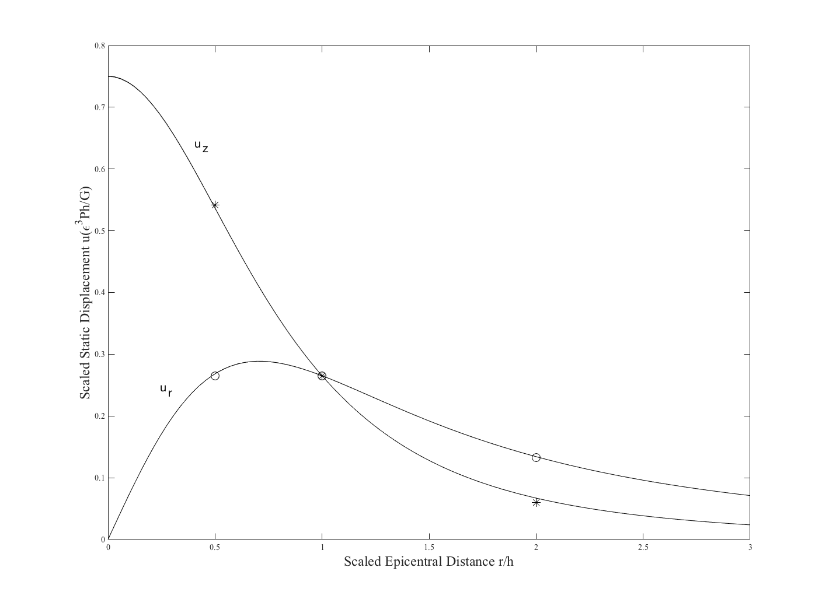

**Figure 9** Dimensionless static surface displacements generated by a spherical pressure source for ** = 0.25 and ** = *rc/h* =1/12 as per Table 1. For this value of ** there is essentially no difference between Mogi’s point dilatation model and McTigues finite volume correction to o(6). The stars and open circles at r/h = 1/2, 1, and 2 show the static limits of *uz* and *ur* respectively as calculated by our model (see Fig. 8)

### Case 2 – Half space with Isotropic Initial Damage

Case 2 models an explosion having the source parameters in Table I and geometry in Fig. 6 for a medium having an isotropic distribution of damage with parameters appropriate for Barre granite as specified in Table 1. A general problem in simulations that involve damage mechanics is how to treat elements that have failed. In the micromechanical damage used here, failure is defined by an instability in which damage increases at decreasing values of the loading stress. Hence the failed regions ability to support the load from neighboring elements decreases due to the unstable accumulation of damage. In our modeling, we use the element deletion procedure in ABAQUS which removes failed elements from the calculation and transfers stresses to neighboring elements.

Figure 10 shows three orthogonal sections through the center of the explosion (the *x-y*, *y-z*, and *x-z* coordinate planes). Damage was limited to a maximum value of *D* = 0.7 since this was the damage at failure in models of triaxial experiments on granite (Ashby and Sammis 1990).

Note in Fig. 10 that the damage pattern is spherical and extends to a radial distance of about two source radii, comparable to the pulverized region in the NEDE experiment (Fig. 2). The red (failed and pulverized) region extends almost the same distance, but has significant deviations from spherical symmetry, possibly due to non-linearity and nascent localizations. These asymmetries are probably not mesh-related since they occur in different azimuths in the different orthogonal sections.

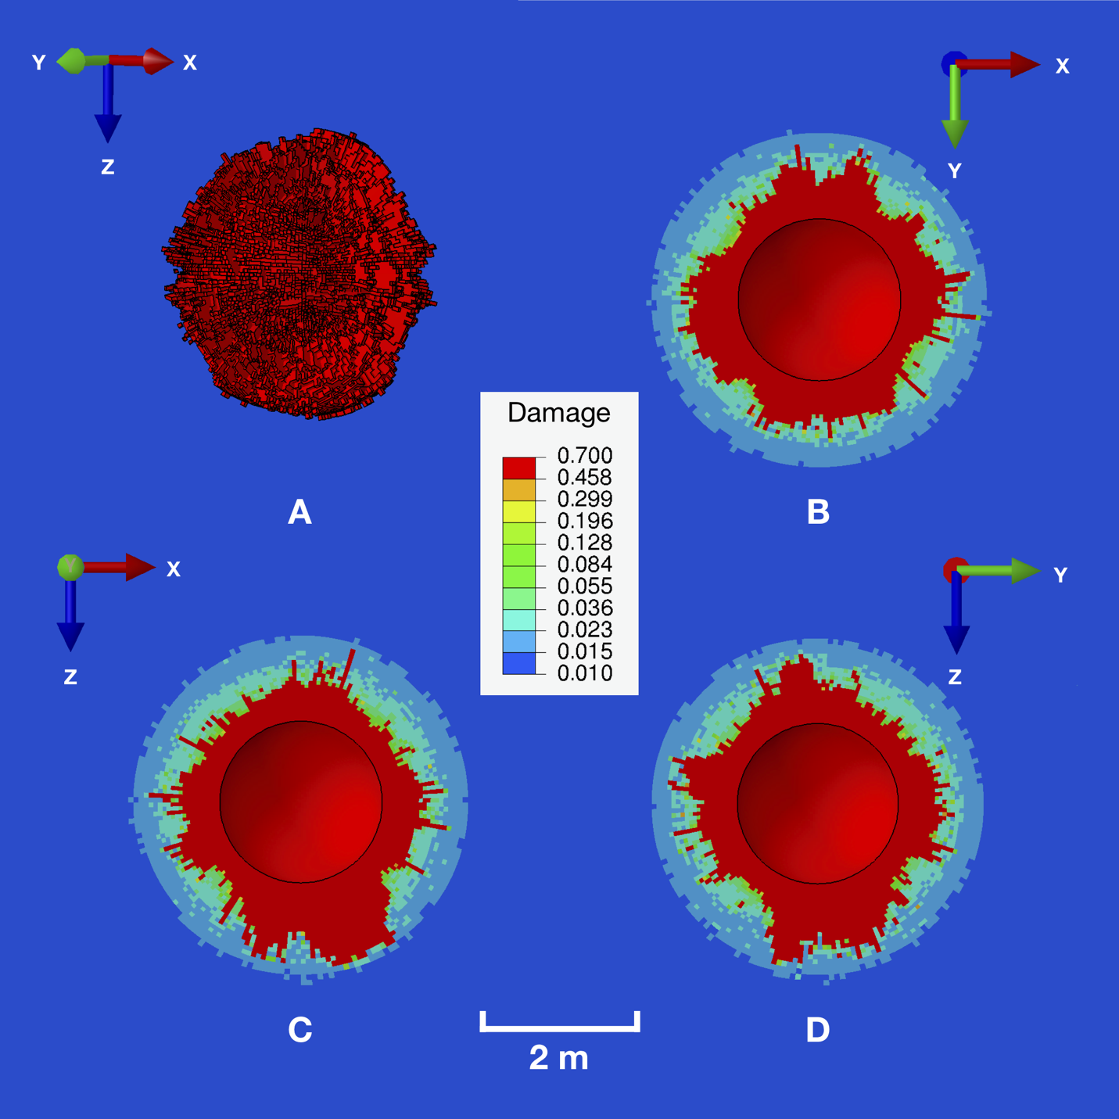

**Figure 10** Damage pattern generated by an explosion in a half-space having the source characteristic of the NEDE #4 experiment and containing the isotropic distribution of initial fractures specified in Table 1. Image A shows a 3D view of all elements having damage greater than D = 0.5. Images B, C, and D show three orthogonal sections through the damage.

It is interesting that there are no radial fractures that extend beyond the failed region as observed in 2D experiments and 2D damage simulations (Mihale et al. 2019). The lack of radial fractures in 3D may be due to random opening directions of wing-cracks which frustrate the growth of any one long fracture. This frustration is evident in Fig. 11 which is a snapshot of failed elements surrounding the cavity just following the initiation of damage. Note the development of orthogonal damage localizations which suppress the evolution of long tensile cracks.

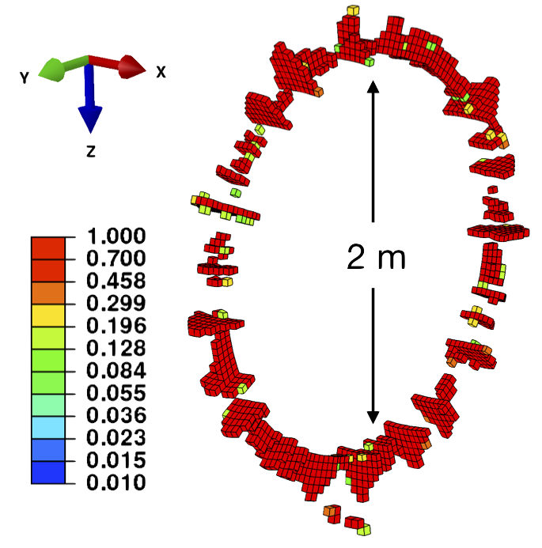

**Figure 11** Snapshot of failed elements surrounding the cavity just following the initiation of damage. Note the development of orthogonal damage localizations which suppress long tensile cracking and make the distribution more isotropic.

Figure 12 shows displacement seismograms calculated using the isotropic damage model. Note that the amplitudes are slightly more than 10 times larger than those predicted by the elastic model. One explanation is that the extensive damage close to the cavity produces a larger effective source radius *R*c. In actuality, the extra fracture volume associated with the damage would lower the pressure. However, our simulations maintain a constant residual pressure. According to Mogi’s equations (25) and (26), increasing *R*c by a factor of 2.3 would increases the static displacement by a factor of 12, as observed. Note that the radius of the highly damaged zone in Fig. 10 is roughly 2m while for the elastic case *Rc* = 1m.

Note also that the overshoot in Fig. 13 is significantly longer than that in Fig. 8 due to the lower elastic modulus in the damaged material behind the shock front. A similarly long overshoot was also observed in nuclear explosions where an elastic granite model gave a much shorter pulse than observed and was the motivation to explore the effects of damage in the source region. ASK JEFF STEVENS FOR REFERENCE

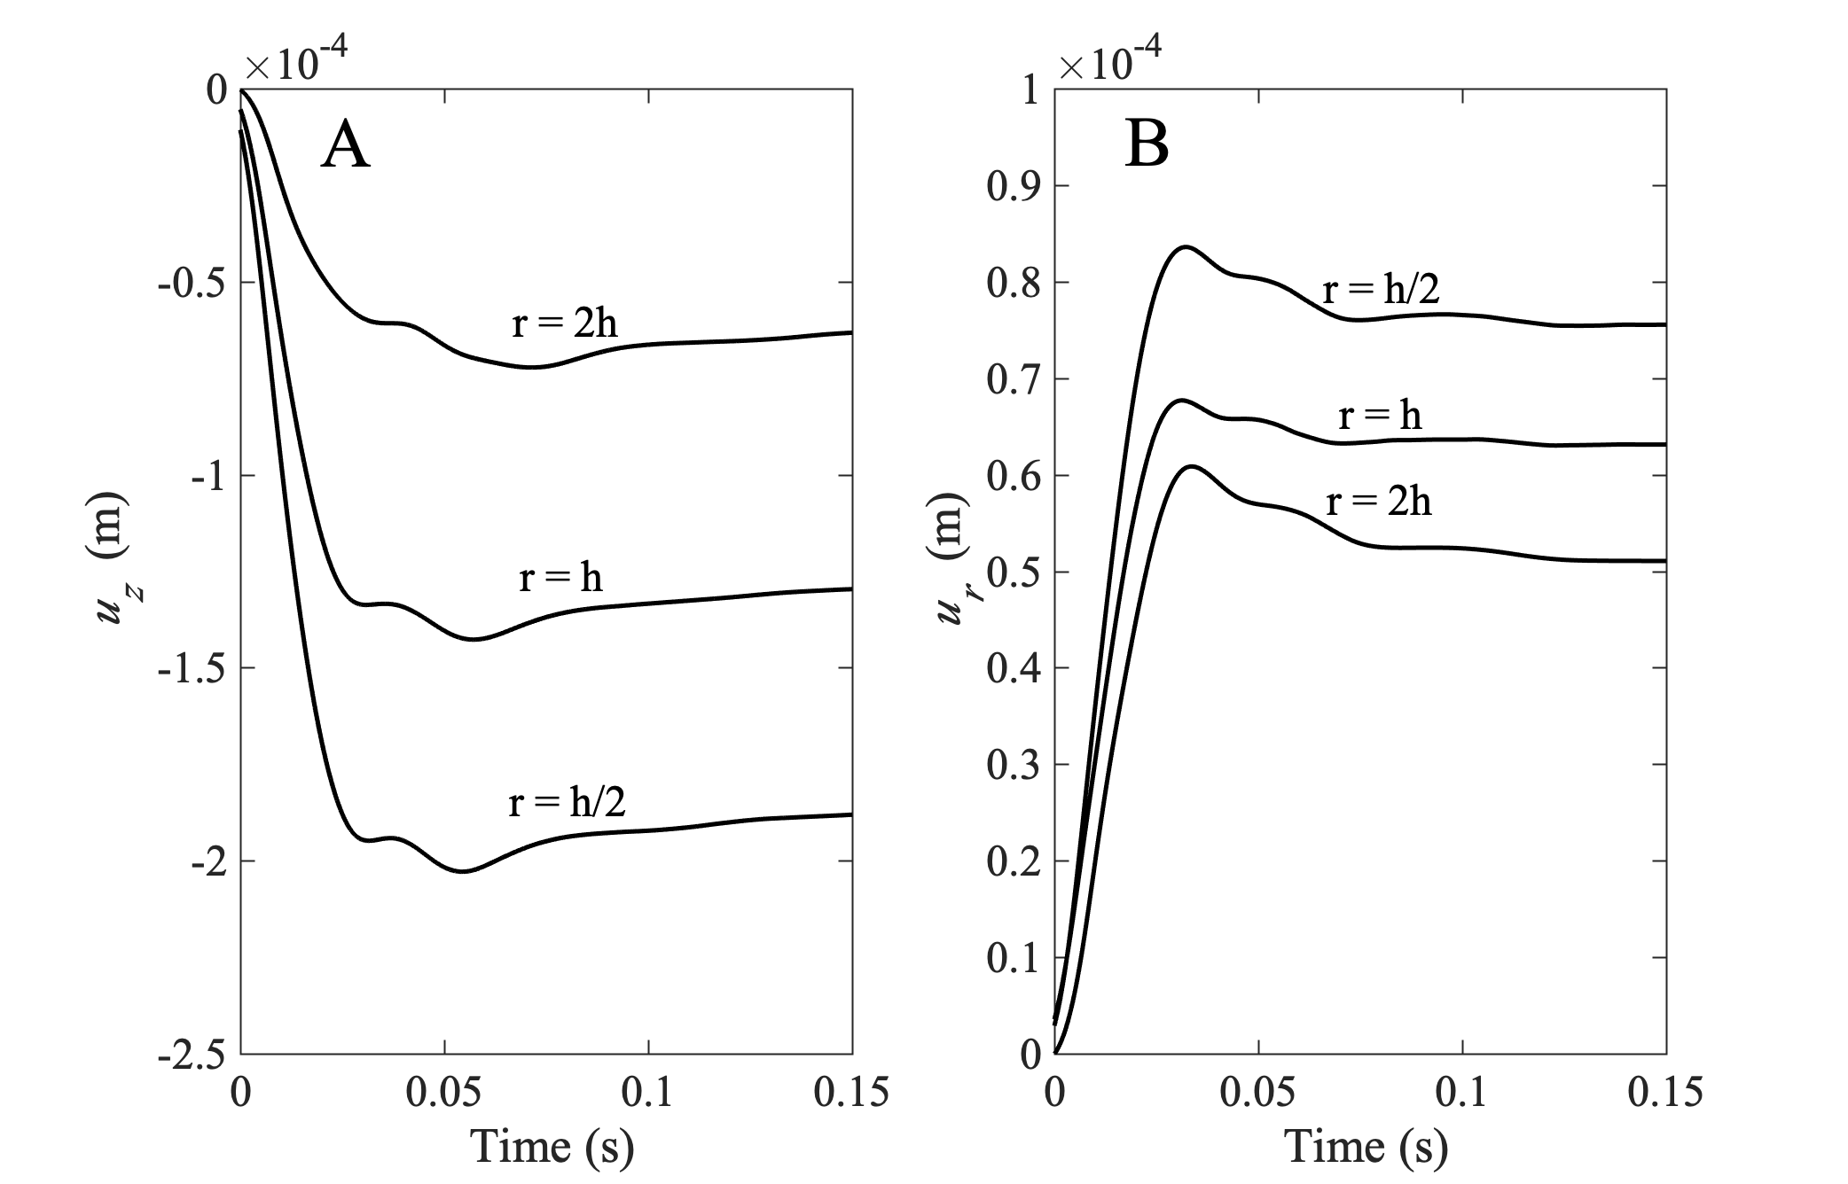

**Figure 12** Displacement seismograms at the free surface for a range of scaled epicentral distances for the case of isotropic initial damage using the source and material properties for NEDE shot #4 given in Table 1. Panel A shows vertical displacements. Note that *z* is positive down as in Fig. 6. Panel B shows horizontal displacements. Note that *r* is the vector from the epicenter to the receiver as in Fig. 6.

### Half Space with Anisotropic Initial Damage

Case 3 models an explosion having the source parameters in Table I and geometry in Fig. 6. in a medium having an anisotropic distribution of initial damage. This case also uses the parameters appropriate for Barre granite as specified in Table 1, but assumes there is a preferential alignment of initial fractures in the rift direction, which is assumed to be a plane normal to the *x*1 direction. As discussed in the previous section, aligned tensile fractures in the rift plane open preferentially in the *x*1 direction. Preferential tensile growth in the rift is achieved by lowering the mode-I critical stress intensity factor for all fractures lying within the rift-zone in Fig. 5. The critical stress intensity factor decreases linearly from its nominal value at the edges of the rift zone to one quarter of its nominal value on the *x*2 – *x*3 coordinate plane. We again use element deletion to define the post-failure behavior.

Figure 13 shows the fracture pattern generated by the anisotropic case. Note that damage in the rift zone now extends to more than 5Rc, comparable to the NEDE observations. Figure 14 shows the displacement seismograms for Case 3. Note that there is now a strong azimuthal dependence on both the P and S wave radiation, which is evident in the radiation patterns in Fig. 15.

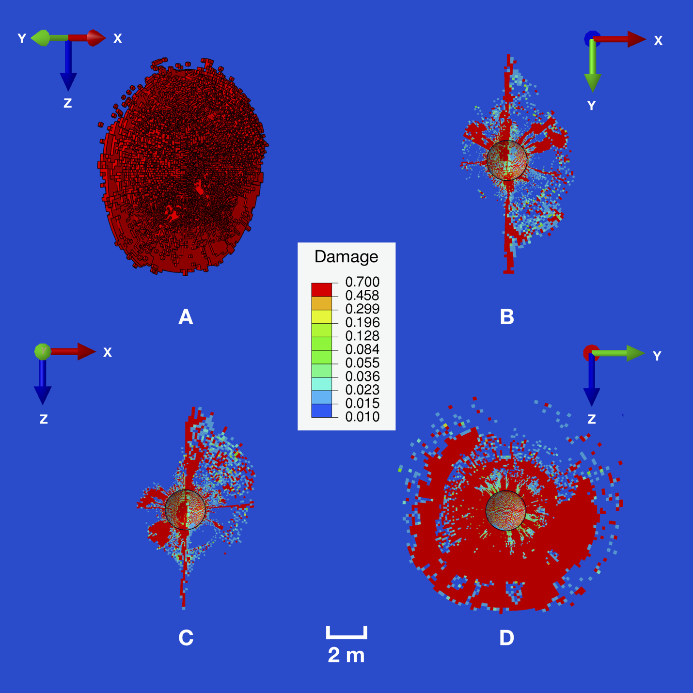

**Figure 13** Damage pattern generated by an explosion in a half-space having the source characteristic of the NEDE #4 experiment and the distribution of initial fractures specified in Table 1. The rift plane is normal to the *x*1 axis. Note that the damage pattern is spatially extended in the rift plane. Image A shows a 3D view of all elements having damage greater than D = 0.5. Images B, C, and D show three orthogonal sections through the damage on the coordinate planes.



**Figure 14** Displacement seismograms at the free surface for a range of scaled epicentral distances for the case of anisotropic initial damage using the source and material properties for NEDE shot #4 given in Table 1. Panel A shows horizontal transverse SH displacements in the ** direction. Panel B shows horizontal radial displacements in the *r* direction where *r* is the vector from the epicenter to the receiver as in Fig. 6. Panel C shows the vertical displacements. Note that *z* is positive down as in Fig. 6.

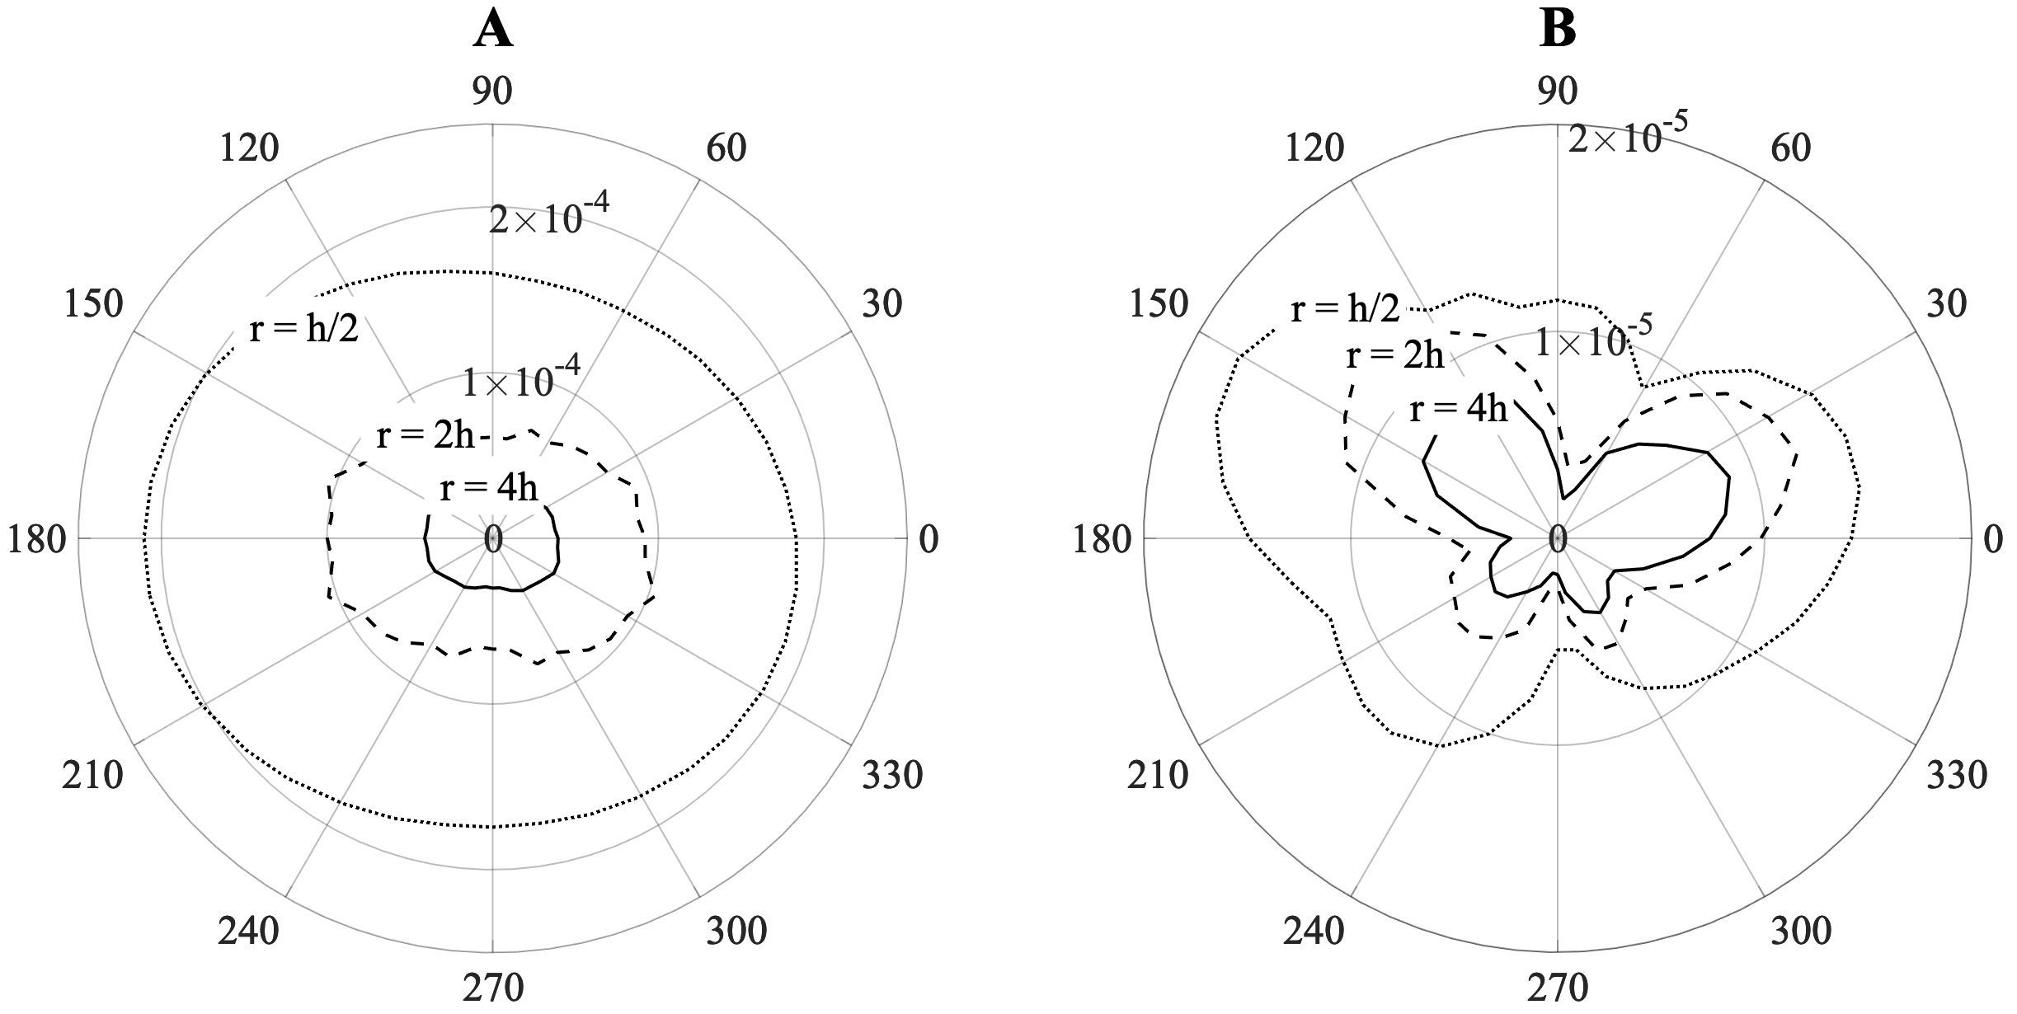

**Figure 15**  Seismic radiation patterns at the free surface for scaled epicentral distances $r=h/2$, 2*h*, and 4*h*, where *z*3 = *h* is the depth of burial. The angle ** is measured from the *x*1 axis. The positive *x*2 axis is at ** = 90o. The rift plane is normal to the *x*1 axis. Panel A shows the P wave pattern while Panel B shows the SH wave pattern.

*Comparison with a Tensile Crack*

Figure 16 shows the far-field point source radiation patterns for P and S waves generated by a tensile crack in an elastic medium projected onto the free surface calculated using expressions in Walter and Brune (1993). Note the similarity to the radiation patterns generated by an explosion in an anisotropic medium in Fig. 15.

]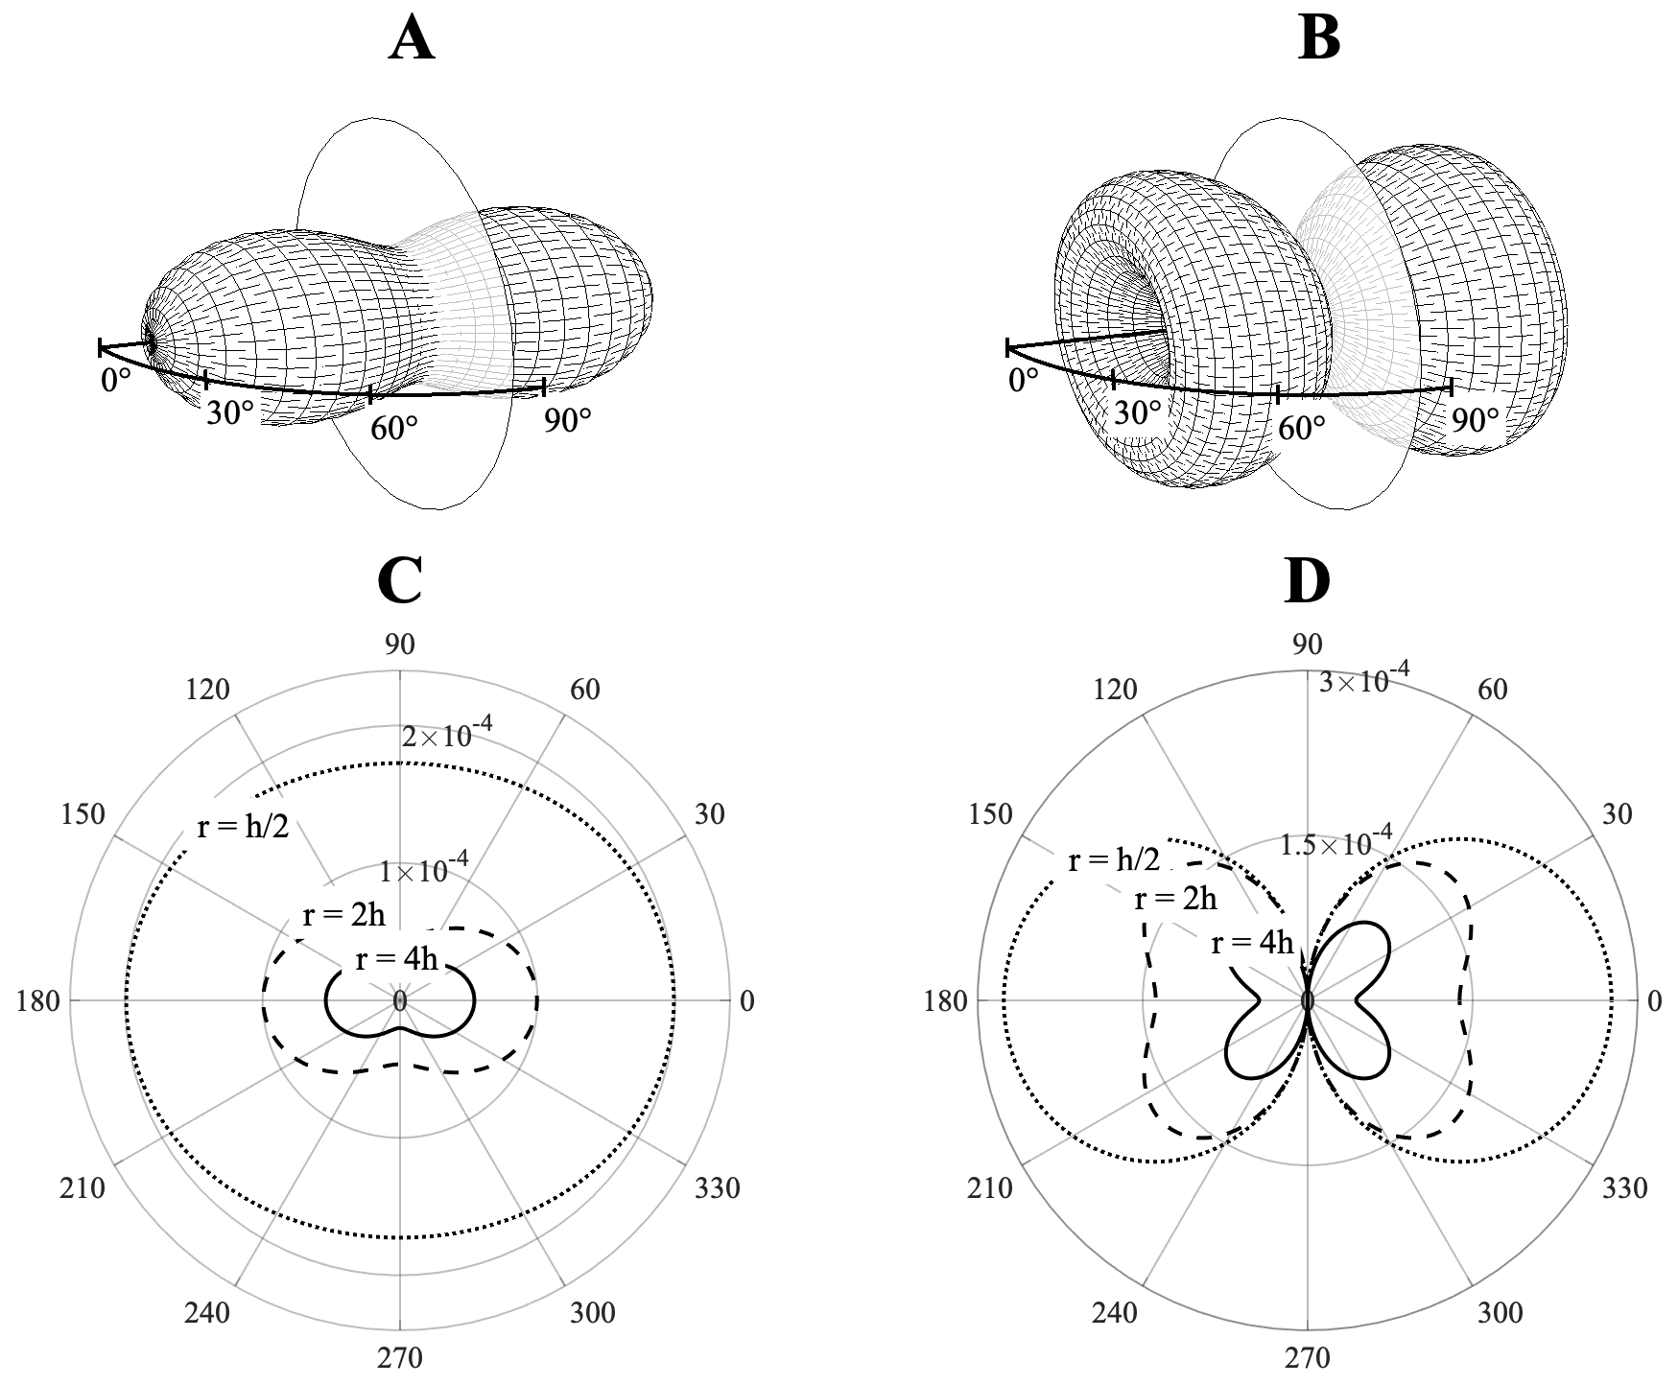

**Figure 16** The far-field, point source, P and S wave radiation patterns for the tensile crack. The absolute amplitude of the radiation pattern from Walter and Brune (1993). The crack plane is vertical as indicated by the circle. The lower panels show the radiation patterns at the free surface generated by a vertical tensile fracture that strikes 90º. The left panels is the P wave pattern, right panel is the S wave pattern

Figure 17shows a comparison of the observed P/S ratio from the NEDE experiment (Stroujkova et al., 2015) with that predicted by a tensile crack parallel to the rift plane. The close agreement implies that opening tensile cracks in the rift plane looks like a large tensile crack.



**Figure 18** Comparison of the observed S/P ratio from the NEDE experiment with that predicted by a tensile crack parallel to the rift plane. Panels A and B show the observed S/P ratios for two shots from Stroujkova et al. (2015). Panel C shows the expect P and S ratios. Note that the maximum S/P ratio is near N70°E consistent with a tensile crack aligned with the rift plane which strikes N30°E in the quarry.

## **Point Force Moment Tensors**

The far-field seismic radiation from any source can be generated by a linear combination of six point-force couples which comprise the elements of the seismic moment tensor. The moment tensor for a spherically symmetric explosion should have equal diagonal elements $M_{11}=M_{22}=M_{33}$ and no off-diagonal elements $M_{12}=M_{23}=M_{31}=0$. The moment tensors of many underground nuclear explosions are not spherically symmetric. When diagonalized, the three principal components are not equal. This asymmetry in the moment tensor is related to the asymmetry that produces the observed S wave radiation.

Ford et al. (2009) plotted 12 earthquakes, 17 nuclear explosions, and 3 mine collapse on a Hudson source-type plot (Hudson et al. 1989). While most explosions were consistent with a pure volume expansion (within the error estimates), 5 were not. The best fit moment tensors for these are given in Table 2 are plotted on a Hudson diagram in Fig. 18. Also included is the moment tensor for the 1993 NPE chemical explosion from Johnson (1994). Note that all plot near the crack like solution and that the vertical component *M*33 is the largest, which suggests a horizontal rift-plane possibly associated with horizontal layering or low-angle dip-slip faulting.

**Table 2. Explosions having Crack-Like sources**

|  |  |  |  |  |  |  |  |
| --- | --- | --- | --- | --- | --- | --- | --- |
| Explosion | Site | *m*b | *m*w | *M*11 | *M*22 | *M*33 | Ref. |
| Kernville | P.M. | 5.3 | 4.75 | 756 | 707 | 1697 | 1 |
| Hornitos | P.M. | 5.4 | 4.72 | 832 | 756 | 1516 | 1 |
| Houston | P.M. | 4.9 | 4.67 | 520 | 556 | 1269 | 1 |
| Junction | P.M. | 4.8 | 4.71 | 593 | 659 | 1295 | 1 |
| Hunters Trophy | R.M. | 3.9 | 3.62 | 14.6 | 14.9 | 33.4 | 1 |
| 1993 NPE | R.M. | 2.7 |  | 80 | 100 | 160 | 2 |

P.M. = Pahute Mesa, R.M. = Rainier Mesa, 1 = Ford et al. (2009), 2 = Johnson (1994)

All of the crack-like explosions in Table 1 were detonated beneath the Pahute Mesa or the Rainier Mesa at the Nevada National Security Site. Both locations contain highly layered volcanic deposits that produce strong horizontal anisotropy.

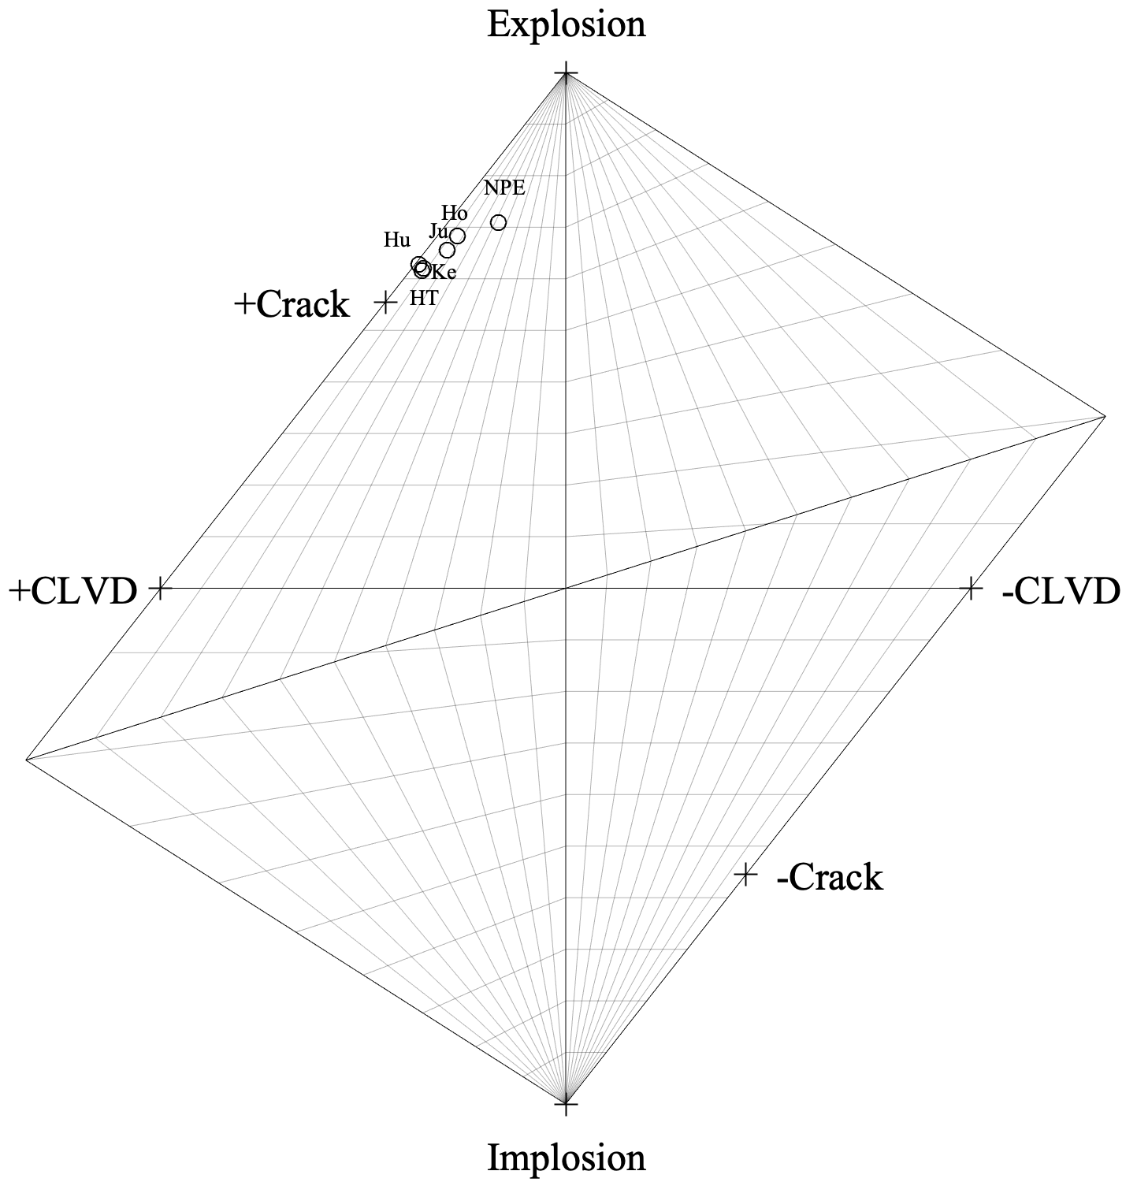

**Figure 18** Hudson source-type plot showing five nuclear explosions having crack-like moment tensors. These are: Ke = Kernville, Ho = Hornitos, Hu = Houston, Ju = Junction, and HT = Hunters Trophy Also shown is the NPE chemical explosion (Johnson 1994). The ordinate measures the amount of volume change for the source, and the abscissa measures the departure from pure Double Couple. Theoretical mechanisms (crosses) are plotted for comparison.

The moment tensor of an underground explosion has two main contributions: the elastic displacement of the cavity wall and the inelastic strain associated with fracture damage to the surrounding rock. While the elastic deformation of the cavity is transient, the relaxation time of the pressure is long compared to period of seismic waves. For the simulations in this paper the final maximum pressure is held constant. The contribution from the cavity wall displacement is

$M_{elastic}=m_{elastic}\left(\begin{matrix}1 & 0 & 0 \\ 0 & 1 & 0 \\ 0 & 0 & 1\end{matrix}\right)$ (27)

$m_{elastic}=4πR_{c}^{2}Pu_{r}=2π\left(\frac{P^{2}}{μ}\right)R_{c}^{3}$ (28)

In this expression, *P* is the pressure in a spherical cavity of radius *Rc*, which produces a radial displacement of the cavity wall of where ** is the shear modulus of the medium. Using the NEDE parameters in Table 1 gives $m_{elastic}=9.12x{10}^{5}$ N-m.

The contribution from damage was calculated in two ways: by integrating the stess glut in each element (detailed in Appendix B) and by summing the contributions from individual cracks (detailed in Appendix C).

For the isotropic distribution of initial damage in Fig. 10, integration of the stress glut using eqns. B12 and B15 from Appendix B gives

$M=\left(\begin{matrix}-4.0 & -0.028 & 0.52 \\ -0.028 & -3.7 & -0.19 \\ 0.52 & -0.19 & -4.0\end{matrix}\right)×10^{9}$ N-m (29)

As expected, the diagonal elements are nearly equal and are between one and two orders of magnitude larger that the off-diagonal elements. The off-diagonal elements arise because the damage in Fig. 10 is not perfectly spherical. Note that the moment due to damage is more than 3 orders of magnitude larger than that due to the elastic displacement of the cavity wall. The corresponding scalar moment is plotted in Fig. 19 where it is seen to be consistent with other explosions.



**Figure 19.** Moment as a function of yield showing that the moment of the NEDE #4 explosion is consistent with other large and small explosions. Redrafted from Denny and Johnson (1991).

The moment can also be estimated as a sum of the contributions from individual cracks using eqn. C10 in Appendix C. For an initial isotropic damage distribution with parameters from Table 1, *Dmax* = 0.7, and assuming Rmax = 2Rc, eqn. (C10) gives

$M=\left(\begin{matrix}-5.7 & 0 & 0 \\ 0 & -5.7 & 0 \\ 00 & 0 & -5.7\end{matrix}\right)×10^{8}$ N-m (30)

These components are almost an order of magnitude smaller than those calculated using the stress-glut method (eqn. 29) which were all about $4x{10}^{9}$ N-m*.* However, in the finite element simulation it was assumed that elements weakened once they failed and their shear modulus was reduced. Reducing the shear modulus in eqn. (C2) can remove this discrepancy.

For the case of an anisotropic distribution of initial fractures (Fig. 14) integration of the stress glut using eqns B12 and B15 from Appendix B gives

$M=\left(\begin{matrix}1.0 & 0.051 & -0.13 \\ 0.051 & 1.1 & 0.039 \\ -0.13 & 0.039 & 1.3\end{matrix}\right)×{10}^{12}$ N-m (31)

This is not the expected result. Cracks in the rift zone should open in the *x*1 direction togive a larger *M*11, and a smaller value for *M*22 = *M*33. The problem is that the opening direction of wing cracks in the Bhat et al. (2012) formulation is random. This is the same problem that frustrates the growth of radial cracks in the isotropic case (Fig. 12). It is a direct consequence of eqn. (4) where the shear is made isotropic by replacing the directional shears with the second invariant of the deviatoric stress tensor (Bhat et al. 2012). While this assumption is ok for isotropic distributions of initial fractures in 2D, it suppresses the growth of tensile cracks in 3D simulations, especially when the initial fracture distribution is anisotropic.

By summing contributions from the individual fractures as in Appendix C we can require that wing cracks in the rift all open in the *x*1 direction. In this case, for parameters used to generate Fig. 14 and the damage geometry in Fig. 14, eqn. (C23) in Appendix C gives

$M=\left(\begin{matrix}-2.6 & 0 & 0 \\ 0 & -0.9 & 0 \\ 00 & 0 & -0.9\end{matrix}\right)×{10}^{9}$ N-m (32)

This moment tensor plots very near a crack-like solution on the Hudson plot.

# 5. Discussion and Conclusions

Shot #4 in the New England Damage Experiment (NEDE) was the first field observation of the fracture damage generated by an explosion in anisotropic granite. Damage was observed to be concentrated in a thin ellipsoid parallel to the rift plane that extended laterally and toward the free surface. This explosion was modeled using the ABAQUS finite element code in concert with micromechanical damage mechanics originally formulated by Ashby and Sammis (1990) and made fully dynamical by Bhat et al. (2012). The ABAQUS subroutine VUMAT, written by Bhat et al. (2012) was modified to allow an anisotropic distribution of initial damage. In concert with rock mechanics experiments, the critical stress intensity factor for tensile cracks propagating in the rift plane was lowered to reflect the closer spacing of aligned fractures in the rift. As expected, the damage zone was elongated parallel to the rift plane, but the extent was less that that observed in the field. Also, as expected, this break in spherical symmetry produced strong S wave radiation. The P and S wave radiation patterns had the form of those produced by a tensile crack aligned with the rift plane and were consistent with the limited seismic data from the NEDE experiment. However, the point force moment tensor calculated from the nonlinear strain associated with the damage did not have the form of a tensile crack.

The failure of the model to produce a physically reasonable moment tensor can be traced to simplifying assumptions introduced by Bhat et al. (2012) to facilitate numerical implementation. First is the assumption in eqn. (4) that the normal stress on a penny crack is represented by the first invariant of the stress tensor (the pressure) and the shear stress by the second invariant the of the deviatoric stress tensor. By making this assumption, there is no account of fracture orientation. Tensile cracks in the rift zone are free to open in any direction when, physically, they should all open normal to the rift.

A second problem is that entry into Regime III (tensile loading) in the subroutine requires that the pressure $σ=\frac{σ_{kk}}{3}$ becomes tensile. However, in reality only the transverse stresses in the outgoing stress wave become tensile while the radial stress remains compressive (Johnson and Sammis 2001). The program will not go into regime III under these circumstances event though the tensile transverse stress should cause both the penny cracks and wing cracks to open in the transverse direction and extend as tensile cracks in the radial direction.

To further explore the moment tensor associated with the anisotropic case we have reformulated the problem as a sum the moment contributions of individual sliding penny-cracks and opening wing-cracks as in Johnson and Sammis (2001). We used the damage distributions from the finite element modeling (Fig. 14) but required that all wing-cracks in the rift zone open in the same (*x*1) direction. We also required that the sliding direction on the penny cracks is consistent with this opening direction. This constraint on the sliding directions of the penny-cracks in the rift zone produced a strong CLVD component to the point-force moment tensor.

The common practice when interpreting Hudson source-type diagrams like Fig. 19 is to assume that the source is a linear combination of an isotopic pressure, a double couple, and a compensated linear vector dipole. Ignoring the small double couple component, the apparent crack-like source in Fig.19 is usually interpreted as a combination of a pressure source and a CLVD source

$\left(\begin{matrix}1 & 0 & 0 \\ 0 & 1/3 & 0 \\ 0 & 0 & 1/3\end{matrix}\right)=\frac{5}{9}\left(\begin{matrix}1 & 0 & 0 \\ 0 & 1 & 0 \\ 0 & 0 & 1\end{matrix}\right)+\frac{4}{9}\left(\begin{matrix}1 & 0 & 0 \\ 0 & -1/2 & 0 \\ 0 & 0 & -1/2\end{matrix}\right)$ (33)

In this interpretation, the CLVD source is ascribed to preferential motion toward the free surface. This seems like a plausible explanation, but the question arises: why do only 5 of the 17 nuclear explosions studied by Ford et al. (2009) have crack-like sources? They are all detonated at the same depth of burial (scaled to their yield). The NPE explosion was over-buried relative to its yield (Johnson 1994), yet it also has a crack-like source. It is interesting that the nuclear explosions showing an larger moment component toward the surface are all from the Pahute and Ranier Mesas which are known to have well-developed horizontal bedding.

Based on the numerical and field studies presented above, we draw the following conclusions:

1. A preferred orientation of microfractures (rift) in rock can produce a strong asymmetry in damage generation leading to S wave generation.
2. The damage occurs preferentially in a narrow ellipse aligned with the rift plane of the rock.
3. Seismic radiation from explosions in anisotropic rock produce moment tensors that look like a tensile crack oriented in the rift plane. Limited seismic data from the NEDE #4 explosion in a granite mine is consistent with a vertical crack aligned with the rift plane in the granite. Several nuclear explosions also have crack-like moment tensors as did the NPE chemical explosion.
4. The largest component of the moment tensor for the crack-like nuclear explosions and the NPE explosion is vertical, which corresponds to a horizontal crack. Whether this is caused by horizontal jointing (as observed at the site of the “Source Physics Experiment”), weak bedding planes, or a surface effect is not clear.

References

Anderson, D.L., B. Minster, and D. Cole (1974). The effect of oriented cracks on seismic velocities*, J. Geophys. Res., 79(26),* 4011-4015.

Ashby, M. F., & Sammis, C. G. (1990). The damage mechanics of brittle solids in compression. *Pure and Applied Geophysics*, *133*(3), 489-521.

Ben-Menahem, A. and A. Cisternas (1963). The dynamic response of an elastic half-space to an explosion in a spherical cavity, Studies in Applied Mathematics, 42(1-4), 112-125.

Bhat, H. S., Rosakis, A. J., & Sammis, C. G. (2012). A micromechanics based constitutive model for brittle failure at high strain rates. *Journal of Applied Mechanics*, *79*(3), 031016.

Bhat, H. S., C. G. Sammis, and A. J. Rosakis (2011). *The Micromechanics of Westerley Granite* *at Large Compressive Loads. Pure Appl. Geophys.* DOI:10.1007/s00024-011-0271-9

Deshpande, V. S., & Evans, A. G. (2008). Inelastic deformation and energy dissipation in ceramics: a mechanism-based constitutive model. *Journal of the Mechanics and Physics of Solids*, *56*(10), 3077-3100.

Ford, S.R., D.S. Dreger, and W.R. Walter, 2009: Identifying isotropic events using a regional moment tensor inversion, J. Geophys. Res., 114, B01306, doi:10.1029/2008JB005743.

Freund, L. B., 1973, “Crack Propagation in an Elastic Solid Subjected to General Loading-iii. Stress Wave Loading,” J. Mech. Phys. Solids, 21, pp. 47–61.

Hudson, J. A., R. G. Pearce, and R. M. Rogers (1989), Source type plot for inversion of the moment tensor, J. Geophys. Res., 94, 765 – 774, doi:10.1029/JB094iB01p00765.

Johnson, L. R., 1994: Recording experiment on Rainier Mesa in conjunctionwith a reflection survey, Lawrence Berkeley Laboratory Publication LBL-35946 (UC-600), 20 pp.

Johnson, L. R., & Sammis, C. G. (2001). Effects of rock damage on seismic waves generated by explosions. *Pure and applied geophysics*, *158*(11), 1869-1908.

Leidig, M., J. L. Bonner, T. Rath, and D. Murray, 2010: Quantification of ground vibration differences from well-confined single-hole explosions with variable velocity of detonation, *Int. J. Rock Mech. Min. Sci.*, **47**, 42-49.

Mandal, B., Toksoz, M. N., Taylor, S. R., Patton, H. J., & Richards, P. G. (1991). Effects of an explosive source in an anisotropic medium. *Explosion Source Phenomenology*, *65*, 261-268.

Martin, R. J., & Boyd, P. J. (2012, January). Characterization of Damage In Anisotropic Rock Due to Buried Explosions. In *46th US Rock Mechanics/Geomechanics Symposium*. American Rock Mechanics Association.

Martin, R, P. Boyd, A. Stroujkova, M. Leidig, J. Lewkowicz and J. Bonner,, 2012: Anisotropy of the Barre Granite in the vicinity of the NEDE, MRR Report.

Martin, R., P. Boyd, A. Stroujkova, J. Lewkowicz, J., and J. Bonner, J., 2011: Correlating near-source rock damage from single-hole explosions to seismic waves. *Proceedings of the 2011 Monitoring Research Review: Ground-Based Nuclear Explosion Monitoring Technologies*, 484-494.

McTigue, D. F. (1987). Elastic stress and deformation near a finite spherical magma body: Resolution of the point source paradox. J. Geophys. Res., 92, B12, 12,931-12,940.

Mihaly, J. M. , C. G.Sammis, A. J. Rosakis, and H. S. Bhat, 2018: Elastic Radiation Generated by a Point Explosion in Breakaway-Glass Plates, in review *J. Geophys. Res*.

Mogi, K. (1958). Relations between the eruptions of various volcanoes and the deformations of the ground surfaces around them, Bull. Earthquake Res. Inst., Univ. Tokyo, 36, 99-134.

Mueller, R. A., & Murphy, J. R. (1971). Seismic characteristics of underground nuclear detonations Part I. Seismic spectrum scaling. *Bulletin of the Seismological Society of America*, *61*(6), 1675-1692.

Nadan, B. J., and T. Engelder, 2009: Microcracks in New England granitoids: A record of thermoelastic relaxation during exhumation of intracontinental crust. *Geological Society* *of America Bulletin*, **121**(1-2), 80-99.

Nasseri, M. H. B., & Mohanty, B. (2008). Fracture toughness anisotropy in granitic rocks. *International Journal of Rock Mechanics and Mining Sciences*, *45*(2), 167-193.

Stroujkova, A., J. L. Bonner, M. Leidig, P. Boyd, & R. J. Martin, 2012: Shear waves from explosions in granite revisited: Lessons learned from the New England damage experiment. *Bulletin of the Seismological Society of America*, **102**(5), 1913-1926.

Stroujkova, A., M. Leidig, &and T. Rath, 2014: Seismic coupling of chemical explosions in intact and fractured granite in Barre, Vermont. *Bulletin of the Seismological Society of America*, doi: 10.1785/0120130328.

Stroujkova, A., Leidig, M., & Bonner, J. L. (2015). Effect of the detonation velocity of explosives on seismic radiation. *Bulletin of the Seismological Society of America*, *105*(2A), 599-611.

Vorobiev, O., Ezzedine, S., Antoun, T., & Glenn, L. (2015). On the generation of tangential ground motion by underground explosions in jointed rocks. *Geophysical Journal International*, *200*(3), 1651-1661.

Walter, W.R., and J. N. Brune, 1993: Spectra of seismic radiation from a tensile crack, *J. Geophys. Res.*, **98**, 4449-4459.

Xia, K., M.H.B. Nasseri, B. Mohanty, F. Lu, R. Chen, and S.N. Luo (2008). Effects of microstructures on dynamic compression of Barre granite, International Journal of Rock Mechanics & Mining Sciences 45, 879–887.

# Appendix A: Source Parameters for NEDE Explosion #4

The source parameters for NEDE explosion #4 and the material parameters for Barre granite are summarized in Table 1 in the text. The sources of these parameters are discussed here.

Explosion #4 was 122.2 kg of Heavy ANFO buried at a depth of 13m. It was a cylindrical charge with a diameter of 22.86 cm and a height of 230cm. The measured burn time was 0.475 msec. The energy released by Heavy ANFO is 3.6 MJ/kg so the 122.2 kg of Heavy ANFO released 439.9 MJ. For comparison to other explosions, this corresponds to 1.05x10-4 kilotons of TNT.

We assumed a cavity radius of $r_{c}=1m$ based on the dimensions of the charge and post-shot core samples from Martin and Boyd (2012) who described damage within about 1 meter of the shot point (region I in Fig. 2) as “highly pulverized/granulated with cavity development (wall collapse) possible. Microscale damage is extreme.”

The maximum pressure that can be contained by spherical cavity depends on the size of the flaws in the rock. For a compressive cavity pressure -*p* the transverse stresses on the wall are tensile (positive):

$$σ_{θ}=σ_{ϕ}=\frac{p}{2}$$

Tensile cracks grow radially from the wall when $p$ reaches a critical value $p_{c}$ given by:

$$σ_{θ}=σ_{ϕ}=\frac{p_{c}}{2}=\frac{K_{Ic}}{\sqrt{πa}}$$

where *a* is the flaw size. Since we assume *a* = 0.5 mm in Barre granite, the maximum pressure is:

$$p_{c}=\frac{2K_{Ic}}{\sqrt{πa}}=\frac{2\left(1 MPa m^{1/2}\right)}{\sqrt{π\left({5x10}^{-4}m\right)}}=50.5MPa$$

The effect of lithostatic pressure - $p_{L}$ can be added to the above equations by noting that when the cavity pressure $p_{c}$ is equal to zero, the circumferential stresses on the sphere are compressive:

$$σ_{θ}=σ_{ϕ}=-{\frac{3}{2}p}_{L}$$

As $p_{c}$ is increased the circumferential stresses become:

$$σ_{θ}=σ_{ϕ}=\frac{p_{c}}{2}-\frac{3p_{L}}{2}$$

The circumferential stresses do not become tensile (positive) until $\left|p_{c}\right|>\left|3p_{L}\right|$. The wall will fail in tension when:

$$σ_{θ}=σ_{ϕ}=\frac{p_{c}}{2}-\frac{3p_{L}}{2}=\frac{K_{Ic}}{\sqrt{πa}}$$

$$\left|p_{c}\right|=\frac{2K_{Ic}}{\sqrt{πa}}+3p_{L}=\frac{2\left(1 MPa m^{1/2}\right)}{\sqrt{π\left({2x10}^{-4}m\right)}}+3\left(0.33\right)MPa=51.5MPa$$

where we have used $p_{L}=0.33MPa$ as the lithospheric stress at 13 m.

We assume a source time function having a rise-time ** of the form:

$p=p_{c}\left(t/τ\right)$ for $t≤τ$

$p=p_{c}$ for $t>τ$

The measured burn time was 47.5 ms. The time for a P wave to travel the 1 m cavity radius is 1/4600 = 0.217 ms. The rise time was taken to be ** = 25 ms based on the 40.9 Hz corner frequency of NEDE explosion #4.

The seismic velocities and density of Barre granite were measured by Martin and Boyd (2012). The initial damage, flaw size, and critical stress intensity factor were assumed to be the same as those determined by Ashby and Sammis (1990) for Westerly granite, which has a similar composition and grain size (Xia et al., 2008). Following Bhat et al. (2012) the branching speed was take to be *vm* = 0.35 *CR*, typical of ceramics with some plasticity. For Barre granite we use

$$\frac{C_{R}}{v_{s}}≈\frac{0.862+1.14υ}{1+υ}$$

and

$$υ=\frac{1}{2}\left(\frac{{\left(\frac{v_{P}}{v_{S}}\right)}^{2}-2}{{\left(\frac{v_{P}}{v_{S}}\right)}^{2}-1}\right)$$

and *vP* and *vS* from Table 1 to calculate *CR*= 2,473 m/s. This gives *vm* = 0.35*CR* = 866 m/s.

**Appendix B**  **Contribution of Damage to the Moment Tensor**

The moment tensor of an underground explosion has two main contributions: the transient elastic displacement of the cavity wall, which can be treated as a permanent deformation as the cavity pressure persists much longer than the explosion rise time, and the inelastic strain associated with damage to the surrounding rock. While the transient elastic contribution can be readily calculated from the cavity size, explosive pressure and elastic properties of the surrounding rock, the contribution from damage is more elusive. This appendix presents a method for calculating the contribution of rock damage to the seismic moment tensor of an underground explosion using the damage mechanics framework of Bhat et al. (2012).

The total strain at (***x****,t*) in any source may be written as a sum of elastic and transformational (inelastic) contributions:

$ε_{ij}\left(x,t\right)= ε_{ij}^{E}\left(x,t\right)+ ε_{ij}^{T}(x,t)$ (B1)

The transformation strain $ε_{ij}^{T}\left(x,t\right)$ is the permanent non-recoverable strain due to changes to the structure of the elastic body, while the elastic strain $ε_{ij}^{E}\left(x,t\right)$ is recoverable.

The seismic moment density tensor, or stress glut, $m_{ij}(x,t)$ is the stress which imparts the permanent deformation $ε_{ij}^{T}\left(x,t\right)$ and is defined as:

$m_{ij}\left(x,t\right)=c_{ijkl}{(x)ε}_{kl}^{T}(x,t)$ (B2)

where $c_{ijkl}$ is the stiffness tensor of the medium *at the time t of the permanent deformation $.$* The total seismic moment tensor $M_{ij}\left(x,t\right)$ is the volume integral of $m_{ij}\left(x,t\right)$ over all volumes in the source that undergo inelastic strain:

$M_{ij}\left(t\right)=\int_{V}{m_{ij}\left(x,t\right)dV}=\int_{V}{c_{ijkl}{(x)ε}_{kl}^{T}(x,t)dV}$ (B3)

During dynamic fracturing, the stiffness tensor continuously changes in time, which makes it difficult to infer the contribution of damage to the seismic moment tensor in lab and field experiments. However, our dynamic model is well suited for understanding this contribution as the stiffness $c_{ijkl}$ is a function of the damage state, *D.*

The transformational strain $ε_{ij}^{T}\left(x,t\right)$ associated with damage is found using the energy-based approach in Bhat et al. (2012). First, variations in stress at constant damage *S* induce a purely elastic response with the elastic stiffness corresponding to S. The stress-strain relation and compliance tensor of the damaged material in terms of a Gibb’s free energy function *W* is:

; (B4)

Let *W* denote the change in the free energy function when the solid undergoes deformation that takes it from damage state *S* to *S+S* at constant $σ_{ij}$. The inelastic strain increment associated with *W* is

(B5)

where the Gibbs free energy function in Regime II is given by

$W\left(σ,D\right)=W^{e}\left(σ\right)+\frac{1}{4G}{\left[A_{1}σ+B_{1}τ\right]}^{2}$ (B6)

and in Regime III by

$W\left(σ,D\right)=W^{e}\left(σ\right)+\frac{1}{4G}{\left[C_{1}σ+E_{1}τ\right]}^{2}$ (B7)

In Regime I the energy doesn’t depend on the damage. In Regimes II and III the inelastic energy has been separated from the elastic energy. The inelastic part of (B6) and (B7) can be used to find the inelastic strain using equation (B4).

For Regime II *W* can be expressed as the difference between two states *a* and *b* at constant stress state ** and * *.

(B8)

The inelastic strain $Δε_{ij}^{T}$ is the derivative of this function with respect to stress as in eqn. (B5):

$Δε_{ij}^{T}=\frac{∂\left(dW(σ,D\right)}{∂σ_{ij}}=\frac{1}{2μ}\left\{\left(A_{1b}σ+B_{1b}τ\right)\left(A_{1b}\frac{dσ}{dσ_{ij}}+B_{1b}\frac{dτ}{dσ_{ij}}\right)-\left(A_{1a}σ+B_{1a}τ\right)\left(A_{1a}\frac{dσ}{dσ_{ij}}+B_{1a}\frac{dτ}{dσ_{ij}}\right)\right\}$ (B9)

Recall that $σ=\frac{σ_{kk}}{3} , τ=\sqrt{\frac{1}{2}S_{ij}S_{ij}}$, and $S_{ij}=σ_{ij}-σδ_{ij}$ which give the following relations:

$\frac{∂σ}{{∂σ}_{ij}}=\frac{1}{3}δ_{ij}$ and $\frac{∂τ}{{∂σ}_{ij}}=\frac{S_{ij}}{2τ}\left(1-\frac{1}{3}δ_{ij}\right)$ (B10)

Using eqns. B10 in B9 gives the inelastic strain $Δε_{ij}^{T}$ in Regime II as

$Δε_{ij}^{T}=\frac{1}{4G}\left\{\left(A_{1b}^{2}-A_{1a}^{2}\right)\frac{2}{3}σδ_{ij}+\left(B_{1b}^{2}-B_{1a}^{2}\right)S_{ij}\left(1-\frac{1}{3}δ_{ij}\right)+2\left(\left(A_{1b}B_{1b}-{A_{1a}B}_{1a}\right)\right)\left(\frac{σ}{2τ}\right)S_{ij}\left(1-\frac{1}{3}δ_{ij}\right)+\frac{τ}{3}δ_{ij}\right\}$ (B11)

Note that $∆ε_{ij}^{T}=0$ if states *a* and *b* are the same.

The incremental moment density in Regime II can be written as:

$Δ m_{ij}=\frac{μ}{Γ}\left\{\left(\frac{3\left(1-2ν\right)}{\left(1+ν\right)}+A_{1b}^{2}-\frac{A_{1b}B_{1b}ε}{γ}\right)Δε_{ij}^{T}+\left(\frac{3ν}{\left(1+ν\right)}+\frac{B_{1b}^{2}}{2}-\frac{A_{1b}^{2}}{3}+\frac{A_{1b}B_{1b}ε}{3γ}\right){∆ε}^{T}δ_{ij}-\left(\frac{A_{1b}B_{1b}}{2}\right)∆γ^{T}δ_{ij}\right\}$ (B12)

where

$Δε^{T}=∆ε_{kk}^{T}$, ${∆γ}^{T}=\sqrt{2∆e_{ij}^{T}eS_{ij}^{T}}$, ${∆e}_{ij}^{T}={∆ε}_{ij}^{T}-\frac{1}{3}∆ε^{T}δ_{ij}$, $Γ=\left[\frac{3\left(1-2ν\right)}{2\left(1+ν\right)}+\frac{3\left(1-2ν\right)B_{1b}^{2}}{4\left(1+ν\right)}+\frac{A_{1b}^{2}}{2}\right]$ (B13)

and the $\frac{ε}{γ}$ like terms are based on the total strain.

The equivalent expression for *W* at constant stress ** and * * in Regime III is:

$ΔW=\frac{1}{4μ}\left\{\left(C_{1b}^{2}σ^{2}+E_{1b}^{2}τ^{2}\right)-\left(C_{1a}^{2}σ^{2}+E_{1a}^{2}τ^{2}\right)\right\}$ (B14)

With the corresponding inelastic strain:

$Δε_{ij}^{T}=\frac{1}{4μ}\left\{\left(C_{1b}^{2}+C_{1a}^{2}\right)\frac{2σ}{3}δ_{ij}-\left(E_{1b}^{2}+E_{1a}^{2}τ^{2}\right)S_{ij}\left(1-\frac{1}{3}δ_{ij}\right)\right\}$ (B15)

and incremental moment density:

$Δ m_{ij}=μ\left\{\left(4{\overline{E}}_{1b}^{2}\right)Δε_{ij}^{T}+\left(2{\overline{C}}_{1b}^{2}-\frac{{4\overline{E}}_{1b}^{2}}{3}\right){∆ε}^{T}δ_{ij}\right\}$ (B16)

where ${\overline{E}}_{1b}^{2}={\left[2+E_{1b}^{2}\right]}^{-1}$ and ${\overline{C}}_{1b}^{2}={\left[\frac{3\left(1-2ν\right)}{\left(1+ν\right)}+C_{1b}^{2}\right]}^{-1}$

# Appendix C. Moment Tensors from Moments of Individually Fractures

The method developed by Johnson and Sammis (2001) can used to find the moment tensor corresponding to a given damage pattern. We do this for two reasons. First, this method is independent of the stress glut integration in Appendix B and can be used as a check. Second, by summing the moments from individual cracks we can control the opening direction of tensile wing cracks in the rift zone. Homogenization of shear stress in the damage model make this impossible using stress glut analysis in Appendix B.

Consider an individual sliding penny-crack and its associated tensile wing-cracks in Fig. 3. Johnson and Sammis (2001) show that the scalar moment tensor per unit volume contributed by the sheared penny-crack is

$m_{s}=\frac{9}{2}\frac{λ+2μ}{2λ+μ}\frac{K_{Ic}}{{\left(πacosχ\right)}^{\frac{1}{2}}}\frac{D_{0}}{sinχ\cos^{2}χ}{\left[{\left(\frac{D}{D_{0}}\right)}^{\frac{1}{3}}-1\right]}^{1/2}$, (C1)

while that for the pair of tensile wing-cracks is

$m_{t}=\frac{3}{2}\frac{{\left(λ+2μ\right)}^{2}}{2μ\left(λ+μ\right)}\frac{K_{Ic}}{{\left(πacosχ\right)}^{\frac{1}{2}}}D_{0}{\left[{\left(\frac{D}{D_{0}}\right)}^{\frac{1}{3}}-1\right]}^{5/2}$. (C2)

Because the contribution of each element to the moment tensor in the fixed source coordinate system $\left(x_{1}, x_{2}, x_{3}\right)$ depends on the orientation of the sliding and wing cracks, Johnson and Sammis (2001) defined a local coordinated system $\left(x_{1}^{'}, x_{2}^{'}, x_{3}^{'}\right)$ for each crack. They assumed that the tensile wing cracks open in the $x_{2}^{'}$ direction, so the moment density tensor in the local coordinate system for the tensile opening is (Aki and Richards, 19xx)

$m^{'}=m_{t}\left[\begin{matrix}ζ & 0 & 0 \\ 0 & 1 & 0 \\ 0 & 0 & ζ\end{matrix}\right]$ (C3)

while that for shear on the penny-crack (whose normal lies in the (*x*2, *x*3) plane) is

$m^{'}=m_{s}\left[\begin{matrix}0 & 0 & 0 \\ 0 & 1 & 0 \\ 0 & 0 & -1\end{matrix}\right]$ (C4)

where

$ζ=\frac{λ}{λ+2μ}=1-2\frac{V_{S}^{2}}{V_{P}^{2}}$ (C5)

The moment contributions in the local coordinate systems can be related to those in the fixed source coordinate system using Euler angles **, **, and ** as indicated in Fig. C1.

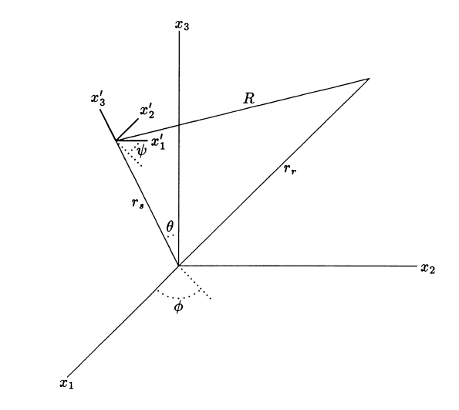

**Figure C1** Euler angles (*  * ) that relate the local coordinate system $\left({x'}_{1}, {x'}_{2}, {x'}_{3}, \right)$ to the fixed coordinate system $\left(x_{1}, x_{2}, x_{3}, \right)$.

From Johnson and Sammis (2001), the components of ***m*** in the fixed source coordinates due to the tensile openings are

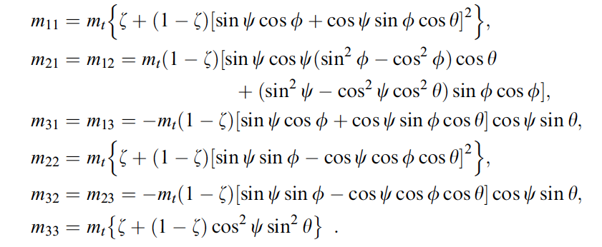(C6)

While those due to the shear are

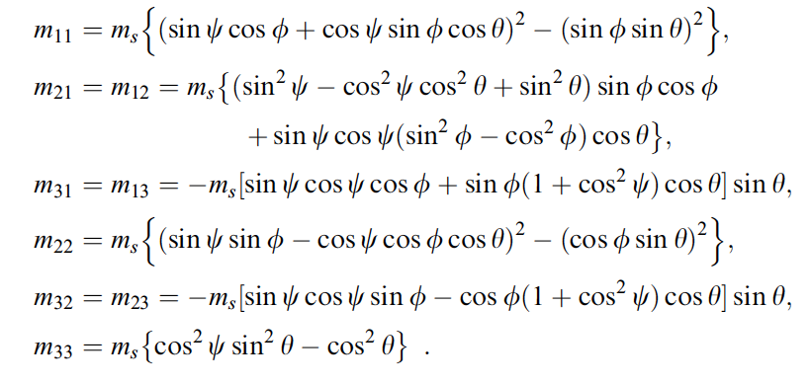(C7)

For an explosion, the largest principal compressive stress in local coordinates lies along the $x_{1}^{'}$ axis which is related to the *x*1 axis by the polar angle **. However, the opening direction of the wing crack, which is specified by **, is not known for a random initial distribution of initial cracks. Since all ** are equally likely for an isotropic initial distribution of fractures we use the average value for each element. Averaging eqn. C6 over all values of **.

(C8)

Assuming that the rock fails at a maximum damage of *Dmax* and that this shell of maximum damage extends from the initial cavity radius of *Rc* out to *Rmax*, the diagonal elements *M*ii of the moment source tensor are

$M_{11}=M_{22}=M_{33}=m_{t}\int_{0}^{2π}{\int_{0}^{π}{\int_{R_{c}}^{R_{max}}{\left[\left(\frac{1+ζ}{2}\right)-\left(\frac{1-ζ}{2}\right)\sin^{2}ϕ\sin^{2}θ\right]}}}r^{2}sinθdrdθdϕ$, (C9)

which gives

$M_{11}=M_{22}{=M_{33}=m}_{t}\frac{4π}{9}\left(1+2ζ\right)\left(R_{max}^{3}{-R}_{c}^{3}\right)$, (C10)

and *mt* is given by equation (C2).

In the isotropic case the contributions from the individual elements to the off-diagonal elements of the moment tensor cancel in the far-field ($M_{12}=M_{23}=M_{31}=0$).

For the anisotropic case assume the rift zone is lies in the *x*2 – *x*3 plane and all cracks in the rift zone open in the *x*1 direction. The rift zone is defined as a wedged shape disc with boundaries making an angle ** relative to the *x*2 - *x*3 plane as in Fig. 5. All elements in the rift zone are assumed to open in the *x*1 direction. The active penny-cracks are oriented such that sliding produces *x1* opening . The orientation of the angle crack and its shear vector thus depend on ** as in Fig. C2.

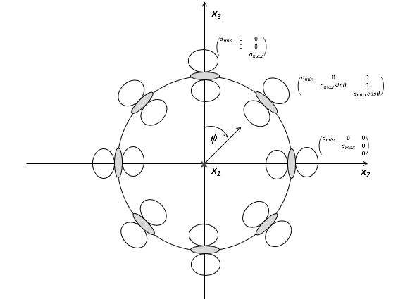

**Figure C2** The orientations of the sliding cracks and their tensile wing cracks as a function of phi in the rift zone. Sliding cracks are shaded grey, wing cracks are white. All wing cracks open in the *x*1 direction.

The moment *M* contributed by cracks in the rift can be written

$M=M_{t}+M_{s}$ (C11)

where *Mt* is from tensile opening of the wing cracks and *Ms* is from shear on the penny-cracks. Since the wing cracks all open in the *x*1 direction, each makes the same contribution to *Mt*

(C12)

where *Vrift* is the volume of the rift and *mt* is the moment per unit volume contributed by a pair of wing cracks given by eqn. (C2). If the rift extends to a distance *Rrift* , its volume is

$V_{rift}=\frac{4}{3}π\left(R_{rift}^{3}-R_{c}^{3}\right)sinβ$ (C13)

and

$M_{t}=m_{t}\frac{4π}{3}\left(R_{rift}^{3}-R_{c}^{3}\right)sinβ\left[\begin{matrix}-1 & 0 & 0 \\ 0 & -1/3 & 0 \\ 0 & 0 & -1/3\end{matrix}\right]$ (C14)

The contribution from each sliding penny-crack depends on its orientation relative to the fixed coordinate system (*x*1, *x*2, *x*3). The contribution to the moment tensor density of sliding cracks at angle ** is

(C15)

Where *ms* is given by eqn. (C1). Note that there is no volume contribution from the sliding cracks at any **. The total contribution of the sliding cracks to the moment tensor in the fixed coordinate system is found by integration over the rift zone

$M_{s}=m_{s}\int_{R_{c}}^{R_{rift}}{\int_{\frac{π}{2}-β}^{\frac{π}{2}+β}{\int_{0}^{2π}{\left[\begin{matrix}-1 & 0 & 0 \\ 0 & \cos^{2}ϕ & 0 \\ 0 & 0 & \sin^{2}ϕ\end{matrix}\right]R^{2}}}}sinθdRdθdϕ$ (C16)

Which gives

$M_{s}=m_{s}\frac{4π}{3}\left(R_{rift}^{3}-R_{c}^{3}\right)sinβ\left[\begin{matrix}-1 & 0 & 0 \\ 0 & 1/2 & 0 \\ 0 & 0 & 1/2\end{matrix}\right]$ (C17)

The net shear contribution *Ms* has the form of a compensated linear dipole with outward fore on the *x*1 axis and equal inward force on the *x2* and *x3* axes.

The total contribution from damage in the rift zone is thus the sum of a crack-like moment and a compensated linear vector dipole moment.

$M=M_{t}+M_{s}=\frac{4π}{3}\left(R_{rift}^{3}-R_{c}^{3}\right)sinβ \left\{m_{t}\left[\begin{matrix}-1 & 0 & 0 \\ 0 & -1/3 & 0 \\ 0 & 0 & -1/3\end{matrix}\right]+m_{s}\left[\begin{matrix}-1 & 0 & 0 \\ 0 & 1/2 & 0 \\ 0 & 0 & 1/2\end{matrix}\right]\right\}$ (C17)

The relative size of the two component depends on the ratio

$\frac{m_{t}}{m_{s}}=\frac{λ+2μ}{3μ}sinχ\cos^{2}χ{\left[{\left(\frac{D}{D_{0}}\right)}^{1/3}-1\right]}^{2}$ (C18)

The relative effect of the tensile component increases as the damage increases.

The damage makes three contributions to the total moment *M*

$M=M_{iso}+M_{crack}+M_{CLVD}$ (C19)

The contribution of from the isotropic damage near the cavity (eqn. C10)

$M_{iso}=m_{t}\frac{4π}{9}\left(1+2ζ\right)\left(R_{max}^{3}-R_{c}^{3}\right)\left(\begin{matrix}-1 & 0 & 0 \\ 0 & -1 & 0 \\ 0 & 0 & -1\end{matrix}\right)$ (C20)

While those from the rift are (eqns. C14 andC17)

$M_{crack}=m_{t}\frac{4π}{3}sinβ\left(R_{rift}^{3}-R_{c}^{3}\right)\left(\begin{matrix}-1 & 0 & 0 \\ 0 & -1/3 & 0 \\ 0 & 0 & -1/3\end{matrix}\right)$ (C21)

$M_{CLVD}=m_{s}\frac{4π}{3}sinβ\left(R_{rift}^{3}-R_{c}^{3}\right)\left(\begin{matrix}-1 & 0 & 0 \\ 0 & 1/2 & 0 \\ 0 & 0 & 1/2\end{matrix}\right)$ (C22)

Equation (C19) can be written

$M=m_{iso}\left(\begin{matrix}-1 & 0 & 0 \\ 0 & -1 & 0 \\ 0 & 0 & -1\end{matrix}\right)+m_{crack}\left(\begin{matrix}-1 & 0 & 0 \\ 0 & -1/3 & 0 \\ 0 & 0 & -1/3\end{matrix}\right)+m_{clvd}\left(\begin{matrix}-1 & 0 & 0 \\ 0 & 1/2 & 0 \\ 0 & 0 & 1/2\end{matrix}\right)$ (C23)

where $M_{11}={-m}_{iso}-m_{crack}-m_{CLVD}$, $M_{22}=M_{33}={-m}_{iso}-\frac{1}{3}m_{crack}+\frac{1}{2}m_{CLVD}$.

The condition for *M* to be crack-like is $M_{22}=M_{33}=\frac{1}{3}M_{11}$, that is

$-m_{iso}-\frac{1}{3}m_{crack}+\frac{1}{2}m_{CLVD}=\frac{1}{3}\left(-m_{iso}-m_{crack}-m_{CLVD}\right)$ (C23)

Equation (C23) gives the following relation between *Rrift*, *Rmax*, *Rc*, and **

… ….(C24)

Equation (C24) is plotted in Fig. C3 in dimensionless form $R_{rift}/R_{max}$ as a function of ** with as a parameter. The filled circle shows the geometry of the observed damage zone in NEDE explosion #4 in Fig. 2 for which $\frac{R_{max}}{R_{c}}≈1.5$ and $\frac{R_{rift}}{R_{max}}≈4$. The inferred with of the rift zone is $β≈1°$ which is consistent with the narrow rift zone shown as an inset in Fig. 2.



**Figure C3** Relative radius of the rift zone Rrift to the isotropic damage zone Rmax for a rage of rift zone widths **. Poisson’s ratio is assumed to be ¼.